**Azure Databricks Mastery:**

**Hands-on project**

**with**

**Unity Catalog,**

**Delta Lake,**

**Medallion Architecture**



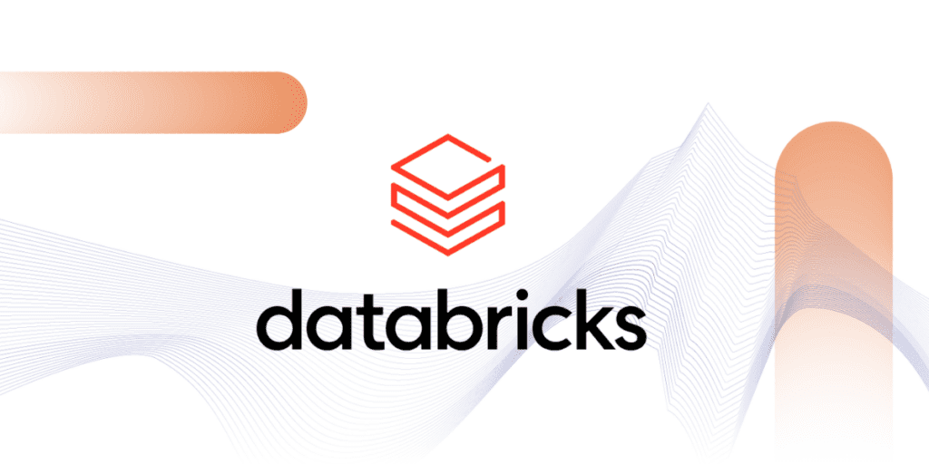

**Azure Databricks Free notes**

**Azure Databricks end to end project with Unity Catalog**

**Azure Databricks Mastery: Hands-on project with Unity Catalog, Delta lake, Medallion Architecture**

Day 1: Sign up for DataBricks dashboard and why DataBricks

Day 2: Understanding notebook and Markdown basics: Hands-on

Day 3: DataBricks in Notebook - Magic Commands: Hands-on

Day 4: DBUitls -Widget Utilities: Hands-on

Day 5: DBUtils - Notebook Utils : Hands-on

Day 6: What is delta lake, Accessing Datalake storage using service principal

Day 7: Creating delta tables using SQL Command

Day 8: Understanding Optimize Command – Demo

Day 9: What is Unity Catalog: Managed and External Tables in Unity Catalog

Day 10: Spark Structured Streaming – basics

Day 11: Autoloader – Intro, Autoloader - Schema inference: Hands-on

Day 12: Project overview: Creating all schemas dynamically

Day 13: Ingestion to Bronze: raw_roads data to bronze Table

Day 14: Silver Layer Transformations: Transforming Silver Traffic data

Day 15: Golder Layer: Getting data to Gold Layer

Day 16: Orchestrating with WorkFlows: Adding run for common notebook in all notebooks

Day 17: Reporting with PowerBI

Day 18: Delta Live Tables: End to end DLT Pipeline

Day 19: Capstone Project I

Day 20: Capstone Project II



# Day 1: Create DataBricks resource using Azure Portal

**Environment Setup: Login to your Azure Portal**

**Step 1: Creating a budget for project: search and type budget, “ADD” on Cost Management, “Add Filter” in “Create budget”, select Service Name: Azure Databricks in drop down menu.**

**Step 2: Set alerts as well in next step. Finally click on “Create”.**

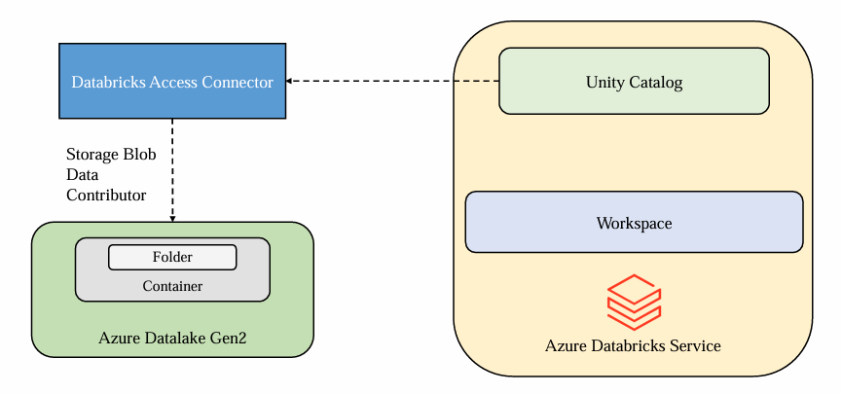

**Step 3: Create a Databricks resource, for “pricing tier”, click here for more details:** [**https://azure.microsoft.com/en-us/pricing/details/databricks/**](https://azure.microsoft.com/en-us/pricing/details/databricks/)

**Hence select for Premium (+ Role based access controls), skip “Managed Resource Group Name”, not any changes required in “Networking”, “Encryption”, “Security”, “Tags” also.**



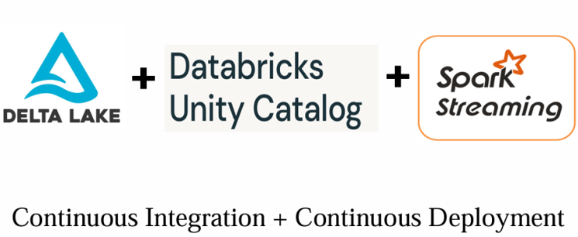

**Step 4: Create a “Storage Account” from “Microsoft Vendor”, select “Resource Group” as previous one, “Primary Service” as “ADLS Gen 2”, select “Performance” as “standard”, “Redundancy” as “LRS”, not any changes required in “Networking”, “Encryption”, “Security”, “Tags” also.**

**Step 5: Walkthough on databricks Workspace UI: click on “Launch Workspace” or go through URL: looks like** [**https://______azuredatbricks.net**](https://______azuredatbricks.net)**, Databricks keep updating UI, click on “New” for “Repo” as CI/CD, “Add data” in “New”, “Workflow” are just like Pipeline at high level, “Search” bar for searching also.**

* **Databricks admin types:** [**https://learn.microsoft.com/en-us/azure/databricks/admin/**](https://learn.microsoft.com/en-us/azure/databricks/admin/)

**Theory 1: What is Big Data approach?: Monolithic is used for Single Computer and distributed Approach using Cluster which is group of computers.**

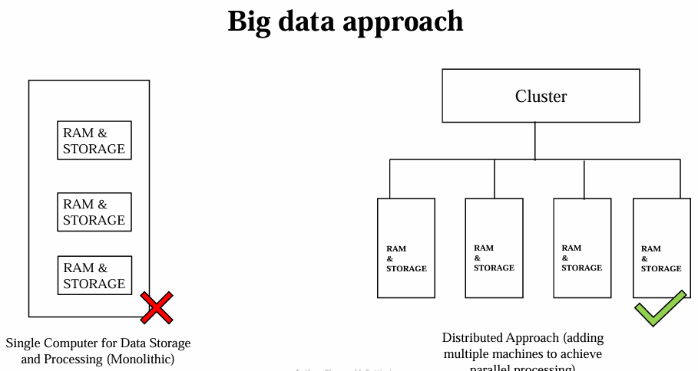

**Theory 2: Drawbacks of MapReduce: In HDFS, in the each iteration, Read and Write operation from disk which will take place high I/O disk costs, developer also have to write complex program, Hadoop is only single super Computer.**

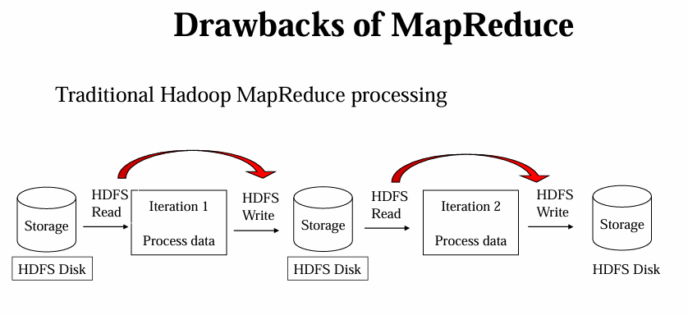



**Theory 3: Emergence of Spark: First it uses HDFS or Any cloud Storage then further process takes place in RAM, it uses in-memory process which is 10-100 times faster than Disk based application, here database is detached from memory and process aloof.**

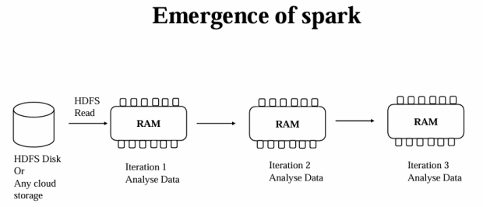

**Theory 4: Apache Spark: it is an in-memory application framework.**

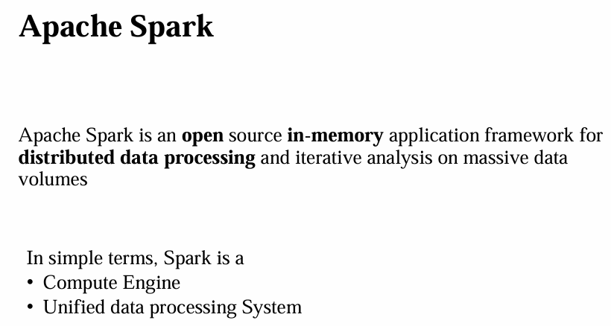

**Theory 5: Apche Spark Ecosystem: Spark Core, special data structure RDD, this is collection of items distributed across the compute nodes in the cluster, these will be processed in parallel, but RDDs are difficult to use for complex operations and they are difficult to optimize , now we are making use of Higher level APIs and libraries like Data Frames and Data Set APIs. Also, uses other high level APIs like Spark SQL, Spark Streaming, Spark ML etc.**

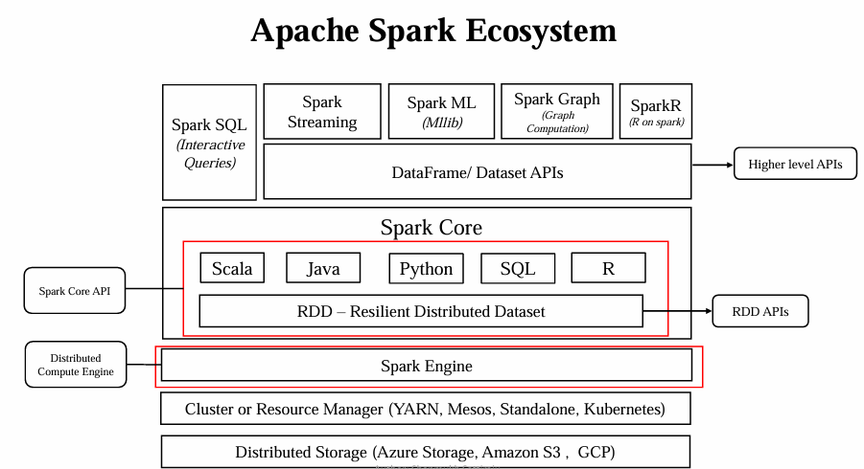

**In the real time, we do not use RDD but higher level APIs to do our programming or coding, data frame APIs to interact with spark and these data frames can be invoked using any languages like Java, Python, SQL or R and internally spark has two parts: set of core APIs, and the Spark Engine: this distributed Computing engine is responsible for all functionalities, there is an OS which will manage this group of computers (cluster) is called Cluster Manager, In Spark, there are many Cluster Managers in which you can use like YARN Resource Manager or Resource standalone, Mesos or Kubernetes.**

**So, Spark is a distributed data processing solution not a storage system, Spark does not come with storage system, can be used like Amazon S3, Azure Storage or GCP.**

**We have Spark Context, which is Spark Engine, to break down the task and scheduling the task for parallel execution.**

**So, what is Databricks? The founders of the Spark developed a commercial product and this is called Databricks to work with Apache Spark in more efficient way, Databricks is available on Azure, GCP and AWS also.**

**Theory 6: What is Databricks?: DB is a way to interact with Spark, to set up our own clusters, manage the security, and use the network to write the code. It provides single interface where you can manage data engineering, data science and data analyst workloads.**

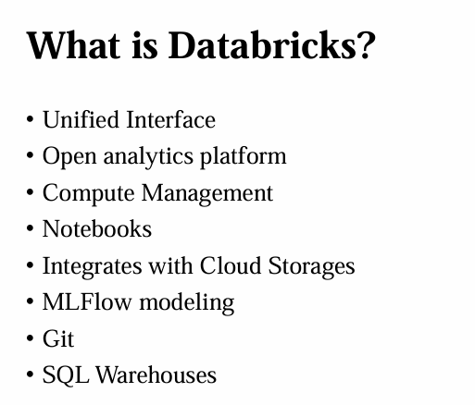

**Theory 7: How Databricks Works with Azure? DB can integrate with data services like Blod storage, Data Lake Storage and SQL Database and security Entra ID, Data Factory, Power BI and Azure DevOps.**

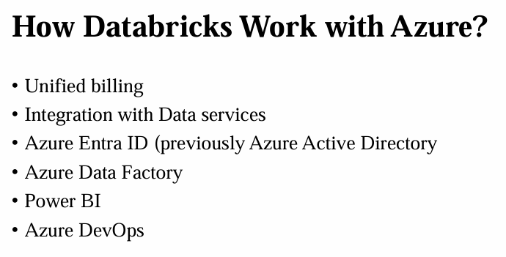



**Theory 8: Azure Databricks Architecture: Control plane is taken care by DB and Compute Plane is taken care by Azure.**

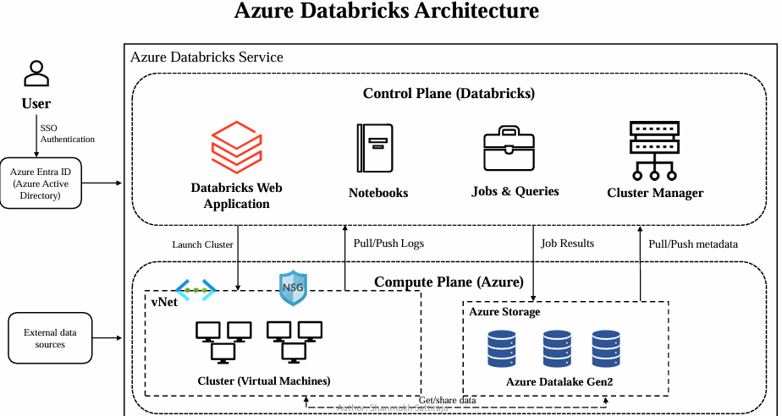

**Theory 9: Cluster Types: All purpose Cluster and Job cluster. Multi-node cluster is not available in Azure Free subscription because it’s allowed to use only maximum of four CPU cores.**

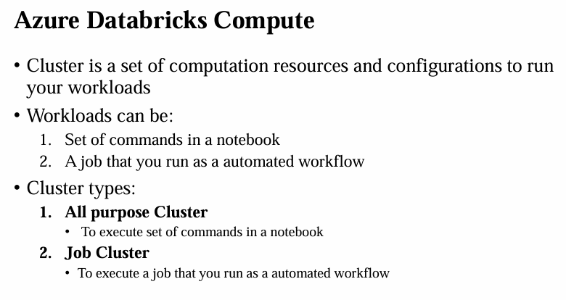

**In DB workspace: (inside Azure Portal), “create cluster”, select “Multi-node”: Driver node and worker node are at different machines. In “Access mode”, if you will select “No isolation shared” then “Unity Catalogue” is not available. Always uncheck “Use Photon Acceleration” which will reduce your DBU/h, can be seen from “Summary” pane at right top.**

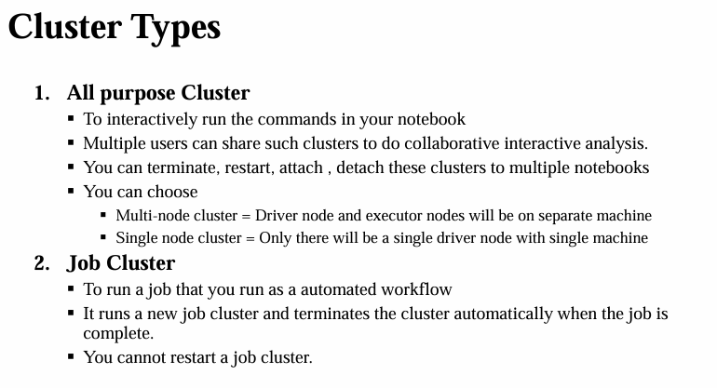

**Theory 10: Behind the scenes when creating cluster: click on “Databricks” instance in Azure portal before clicking on Databricks “Launch Workspace”, there is “Managed Resource Group”: open this link; there is a Virtual network and Network security group and Storage account.**

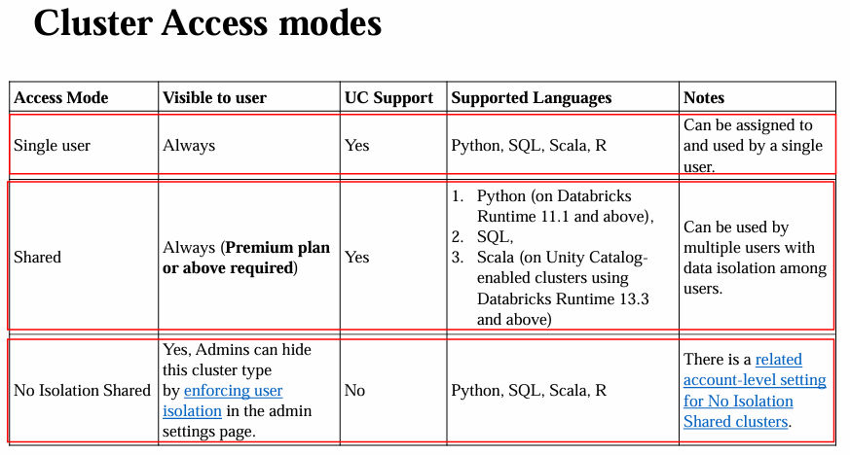

**This Storage account is going to store Meta Data of it, we will see Virtual Machine, when we will create any compute Resource, now go to Databricks workspace, create any compute resource and then come back here, will find some disks, Public IP address and VM. For all these, we will be charged as DBU/h.**

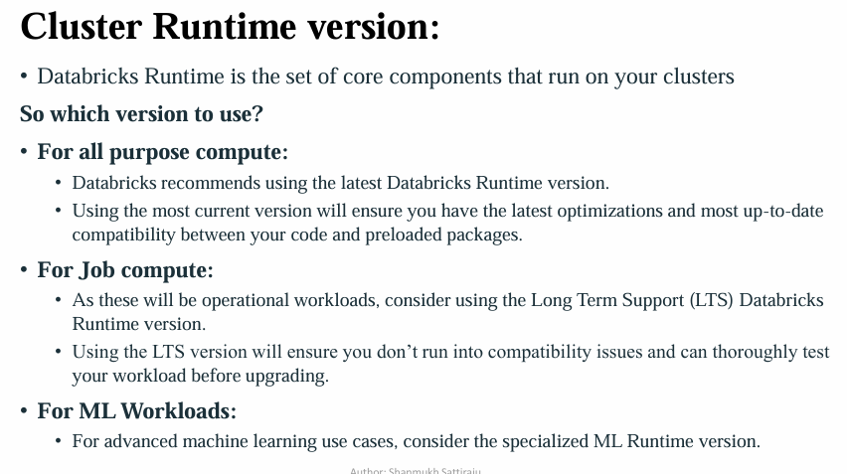

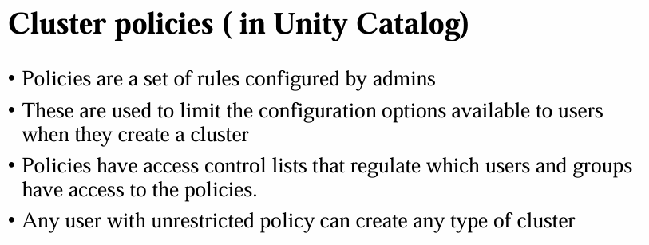

**Stop our compute resource, nothing is deleted in Azure portal, but when we will click on Virtual Machine, then that will show not “start”. But if you delete compute resource from Databricks workspace, check your Azure portal again, will find all resources i.e. disks, Public IP address and VM etc are deleted.**



# Day 2: Understanding notebook and Markdown basics : Hands-on

**Note: this part can be executed in Databricks Community edition, not necessarily to be run in Azure Databricks resource**

%md

### Heading 3

#### Heading 4

##### Heading 5

###### Heading 6

####### Heading 7

-----------------------------------------------------------------

%md

# This is a comment

-----------------------------------------------------------------

%md

1. HTML Style <b> Blod </b>

2. Astricks style **Blod**

-----------------------------------------------------------------

%md

*Italics* style

-----------------------------------------------------------------

%md

`print(df)` is the statement to print something

```

This

is multiline

code

```

-----------------------------------------------------------------

%md

- one

- two

- three

-----------------------------------------------------------------

%md

To highlight something

<span style="background-color: #FFFF00"> Highlight this </span>

-----------------------------------------------------------------

%md

![Profile Pic](<https://media.licdn.com/dms/image/C4E03AQGx8W5WMxE5pw/profile-displayphoto-shrink_400_400/0/1594735450010?e=1705536000&v=beta&t=_he0R75U4AKYCbcLgDRDakzKvYZybksWRoqYvDL-alA>)

-----------------------------------------------------------------

%md

Click on [Profile Pic](https://media.licdn.com/dms/image/C4E03AQGx8W5WMxE5pw/profile-displayphoto-shrink_400_400/0/1594735450010?e=1705536000&v=beta&t=_he0R75U4AKYCbcLgDRDakzKvYZybksWRoqYvDL-alA)

# Day 3: DataBricks in Notebook - Magic Commands : Hands-on

**Magic commands in Databricks: if any SQL command is to be executed then select 'SQL'.**

**Note: this part can be executed in Databricks Community edition, not necessarily to be run in Azure Databricks resource**

**1. Select 'Python' from top and type**

**print('hello')**

**#Comments**

**Default language is Python**

-----------------------------------------------------------------

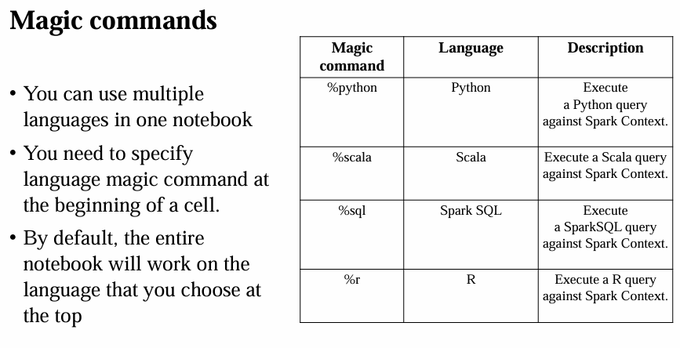

**2. %scala**

**print("hello") will work and also #comments will also not work.**

**For comments in Scala use //Comments**

-----------------------------------------------------------------

**3. Comments in SQL -- Comments**

**now in %sql**

**select 2+5 as sum**



**4. in %r**

**x <-"Hello"**

**print(x)**

-----------------------------------------------------------------

**5. There are much more magic commands in DB.**

**%fs ls**

**List all things in all the directories inside DBFS ie Databricks File System.**

-----------------------------------------------------------------

**6. Know all the Magic commands available:**

**type:**

**%lsmagic**

-----------------------------------------------------------------

**7. Summary of Magic commands: You can use multiple languages in one notebook and you need to specify language magic commands at the beginning of a cell. By default, the entire notebook will work on the language that you choose at the top.**

-----------------------------------------------------------------

**DBUtils:**

**# DBUtils: Azure Databricks provides set of utilities to efficiently interact with your notebook.**

**Most commonly used DBUtils are:**

**1. File System Uttilities**

**2. Widget Utilities**

**3. Notebook Utilities**

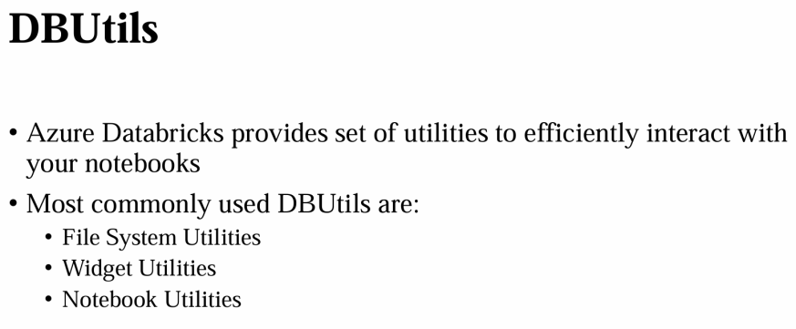

-----------------------------------------------------------------

**1. What are the availble utilities?**

**# just type:**

**dbutils.help()**

-----------------------------------------------------------------

**# 2. Lets see File System Utilities**

**%md**

**# File System Utilities**

**# click new cell:**

**# type:**

**dbutils.fs.help()**

-----------------------------------------------------------------

**#### Ls utility**

**# what are available list in particular directory: Enable DBFS, click on "Admin setting" from right top, click on "Workspace Settings",**

**# scroll down, enable 'DBFS File Browser', now you can see 'DBFS' tab, after clicking on 'DBFS' tab, some set on folders are there,**

**You will find "FileStore" in left pane in “Catalog” button, somewhere, copy path from "spark API format",**

**path = 'dbfs:/FileStore'**

**dbutils.fs.ls(path)**

**# why ls, see just above from dbutils.fs.help() details.**



-----------------------------------------------------------------

**# remove any directory:**

**# just copy following addres from above:such as FileInfo(path='dbfs:/FileStore/temp/', name='temp/', size=0, modificationTime=0)**

**dbutils.fs.rm('dbfs:/FileStore/CopiedFolder/',True)**

**# True is added bcs if this file is not exisiting than it will just reply 'True'**

**# just check directory list again, that file has been removed.**

**dbutils.fs.ls(path)**

-----------------------------------------------------------------

**#### mkdir**

**# why heading are important bcs, left side "Table of Contents" are there, which showing all the headings**

**dbutils.fs.mkdirs(path+'/SachinFileTest/')**

-----------------------------------------------------------------

**# list all files so that we can see newly created directory is there or not?**

**dbutils.fs.ls(path)**

**### put: Inside a folder lets put something,**

**dbutils.fs.put(path+ '/SachinFileTest/test.csv','1, Test')**

-----------------------------------------------------------------

**# also check using manual "DBFS" tab**

**### head : read the file conten, which we just written,**

**filepath = path+ '/SachinFileTest/test.csv'**

**dbutils.fs.head(filepath)**

**dbutils.fs.head("/Volumes/main/default/my-volume/data.csv", 25)**

**This example displays the first 25 bytes of the file data.csv located in /Volumes/main/default/my-volume/.**

-----------------------------------------------------------------

**### Copy: Move this newly created file from one location to another**

**source_path = path+ '/SachinFileTest/test.csv'**

**destination_path = path+ '/CopiedFolder/test.csv'**

**dbutils.fs.cp(source_path,destination_path,True)**

-----------------------------------------------------------------

**# display content from recently pasted values**

**dbutils.fs.head(destination_path)**

-----------------------------------------------------------------

**# same activity can be done by right click of that file *.csv**

**# with "Copy path", "Move", "Rename", "Delete"**

-----------------------------------------------------------------

**# Move is cut and paste/move**

**# copy is just copy and paste**

**source_path = path+ '/FileTest/test.csv'**

**destination_path = path+ '/MovedFolder/test.csv'**

**dbutils.fs.mv(source_path,destination_path,True)**

-----------------------------------------------------------------



**# remove folder**

**dbutils.fs.rm(path+ '/MovedFolder/',True)**

**dbutils.fs.help()**

-----------------------------------------------------------------

# Day 4: DBUitls -Widget Utilities : Hands-on

**Note: this part can be executed in Databricks Community edition, not necessarily to be run in Azure Databricks resource**

**Why Widgets: Widgets are helpful to parameterize the Notebook, imagine, in real world you are working in heterogeneous environment, either in DEV env, Test env or Production env, to change everywhere, just parameterize the notebook, instead of hard coding the values everywhere.**

**Details: Coding:**

**# what are vailavle tools, just type:**

**dbutils.widgets.help()**

**------------------------------**

**%md**

**## Widget Utilities**

**------------------------------**

**%md**

**## Let's start with combo Box**

**### Combo Box**

**dbutils.widgets.combobox(name='combobox_name',defaultValue='Employee',choices=['Employee','Developer','Tester','Manager'],label= "Combobox Label ")**

**------------------------------**

**# Extract the value from "Combobox Label"**

**emp=dbutils.widgets.get('combobox_name')**

**# dbutils.widgets.get retrieves the current value of a widget, allowing you to use the value in your Spark jobs or SQL Queries.**

**print(emp)**

**type(emp)**

**------------------------------**

**# DropDown Menu**

**dbutils.widgets.dropdown(name='dropdown_name',defaultValue='Employee',choices=['Employee','Developer','Tester','Manager'],label= "Dropdown Label")**

**------------------------------**

**# Multiselect**

**dbutils.widgets.multiselect(name='Multiselect_name',defaultValue='Employee',choices=['Employee','Developer','Tester','Manager'],label= "MultiSelect Label")**

**------------------------------**

**# Text**

**dbutils.widgets.text(name='text_name',defaultValue='',label="Text Label")**



**------------------------------**

**dbutils.widgets.get('text_name')**

**# dbutils.widgets.get retrieves the current value of a widget, allowing you to use the value in your Spark jobs or SQL Queries.**

**------------------------------**

**result = dbutils.widgets.get('text_name')**

**print(f"SELECT * FROM Schema.Table WHERE Year = {result}")**

**------------------------------**

**# go to Widget setting from right, change setting to "On Widget change"--> "Run notebook", now entire notebook is getting executed**

**print('execute theseeeSachin ')**

# Day 5: DBUtils - Notebook Utils : Hands-on

**Note: this part can be executed in Azure Databricks resource, not in Databricks Community edition, otherwise it will give like: To enable notebook workflows, please upgrade your Databricks subscription.**

**Create a compute resource with Policy: “Unrestricted”, “Single node”, uncheck “Use Photon Acceleration”, select least node type,**

**Now go to Workspace-> Users-> your email id will be displayed, add notebook from right, click on “notebook” rename as**

**Notebook 1: “Day 5: Part 1: DBUtils Notebook Utils: Child”**

**dbutils.notebook.help()**

**-------------------------**

**a = 10**

**b = 20**

**-------------------------**

**c = a + b**

**-------------------------**

**print(c)**

**-------------------------**

**# And I'm going to use the exit here. So basically what exit will do is it is going to execute all the commands before that. And it is going to come here. And if ever there is an exit command, it is going to stop executing the notebook at that particular point and it is going to return the value, whatever you are going to enter here.**

**dbutils.notebook.exit(f'Notebook Executed Successfully and returned {c}')**

**# We are going to access this notebook in another Notebook**

**-------------------------**

**print('Test')**



**Notebook 2: “Day 5: Part 2: DBUtils Notebook Utils: Parent”**

**print('hello')**

**-------------------------**

**dbutils.notebook.run('Day 5 Part 1 DBUtils Notebook Utils Child',60)**

**60 is timeout parameter**

**Click on “Notebook Job”, will lend you to “Workflow”, where it is executed as job, there are two kinds of clusters, one is interactive and another is “Job”, it’s executed as a “Job”, under “Workflow”, check all “Runs”.**

**Now “clone” Notebook 1: “Day 5: Part 1: DBUtils Notebook Utils: Child” and Notebook 2: “Day 5: Part 2: DBUtils Notebook Utils: Parent” and rename as “Day 5: Part 3: DBUtils Notebook Utils: Child Parameter” and “Day 5: Part 4: DBUtils Notebook Utils: Parent Parameter”**

**Notebook 3: “Day 5: Part 1: DBUtils Notebook Utils: Child Parameter”**

dbutils.notebook.help()

---------------------------

dbutils.widgets.text(name='a',defaultValue='',label = 'Enter value of a ')

dbutils.widgets.text(name='b',defaultValue='',label = 'Enter value of b ')

---------------------------

a = int(dbutils.widgets.get('a'))

b = int(dbutils.widgets.get('b'))

**# The dbutils.widgets.get function in Azure Databricks is used to retrieve the current value of a widget. This allows you to dynamically incorporate the widget value into your Spark jobs or SQL queries within the notebook.**

---------------------------

c = a + b

---------------------------

print(c)

---------------------------

dbutils.notebook.exit(f'Notebook Executed Successfully and returned {c}')

**Notebook 4: “Day 5: Part 4: DBUtils Notebook Utils: Parent Parameter”**

print('hello')

-------------------

dbutils.notebook.run(Day 5: Part 1: DBUtils Notebook Utils: Child Parameter',60,{'a' : '50', 'b': '40'})

**# 60 is timeout parameter**

**# go to Widget setting from right, change setting to "On Widget change"--> "Run notebook", now entire notebook is getting executed**

**On right hand side in “Workflow” 🡪 “Runs”, there are Parameters called a and b.**



# Day 6: What is delta lake, Accessing Datalake storage using service principal:

* **Introduction to section Delta Lake: Delta is a key feature in Azure Databricks designed for managing data lakes effectively. It brings ACID transactions to Apache Spark and big data workloads, ensuring data consistency, reliability, and enabling version control. Delta helps users maintain and track different versions of their data, providing capabilities for rollback and audit.**

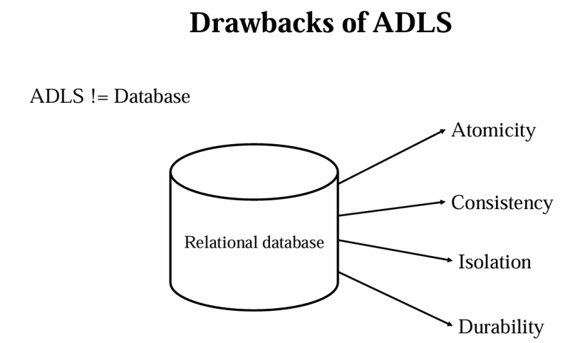

* **In this section, we will dive into Delta Lake, where the reliability of structured data meets the flexibility of data lakes.**
* **We'll explore how Delta Lake revolutionizes data storage and management, ensuring ACID transactions and seamless schema evolution within a unified framework.**
* **Discover how Delta Lake enhances your data lake experience with exceptional robustness and simplicity.**

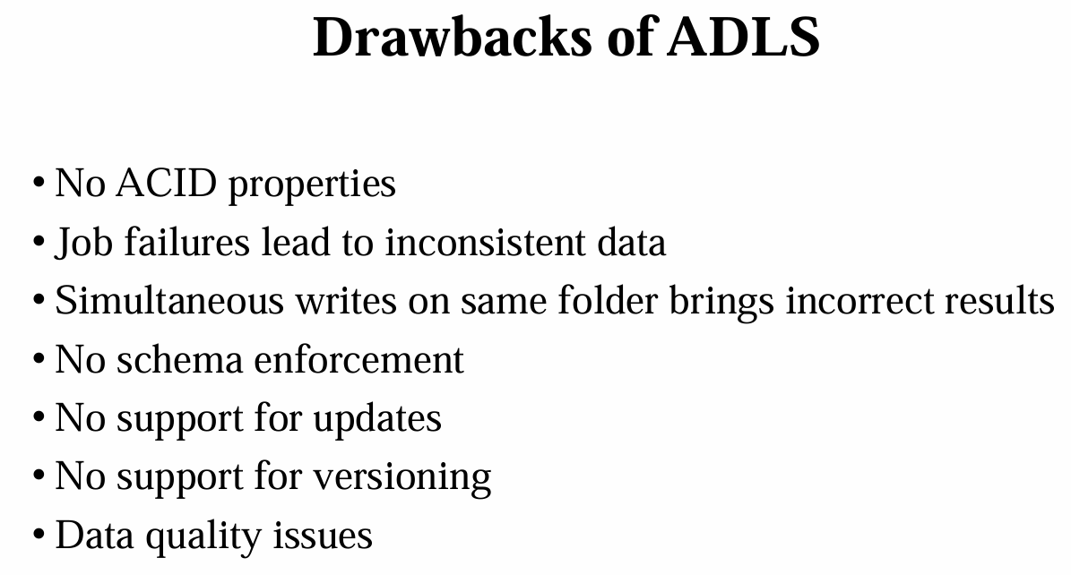

* **We'll cover the key features of Delta Lake, accompanied by practical implementations in notebooks.**
* **By the end of this section, you'll have a solid understanding of Delta Lake, its features, and how to implement them effectively.**
* **ADLS != Database, in RDBMS there is called ACID Properties which is not available in ADLS.**

**Data Lake came forward to solve following drawback of ADLS:**

* **Drawbacks of ADLS:**

1. **No ACID properties**
2. **Job failures lead to inconsistent data**
3. **Simultaneous writes on same folder brings incorrect results**
4. **No schema enforcement**
5. **No support for updates**
6. **No support for versioning**
7. **Data quality issues**



* **What is Delta Lake?**
* **It is an Open-source framework that brings reliability to data lakes.**
* **Brings transaction capabilities to data lakes.**
* **Runs on top of your existing data lake and supports parquet.**
* **Delta Lake is not a data warehouse or a database.**
* **Enables Lakehouse architecture.**

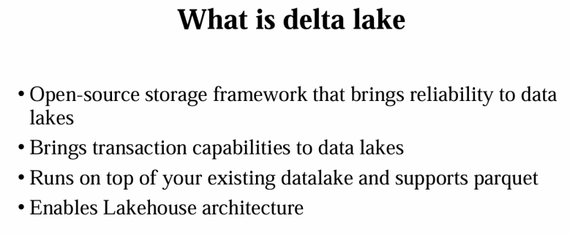

**A. Datawarehouse can work only on structure data, which is first generation evolution. However it is supporting ACID properties. One can delete, update and perform data governance on it.**

**Datawarehouse cannot handle the data other than structure cannot serve a ML use cases.**

**B. Modern data warehouse architecture: There is Modern data warehouse architecture, which includes usage of Data Lakes for object storage, which is cheaper option for storage, this also called two tier architecture.**

**So the best features would be first one.**

**It supports the any kind of data can be structured or unstructured, and the ingestion of data is much faster. And the data lake is able to scale to any extent. And let us see what the drawbacks here are.**

**Like we have seen, Data Lake cannot offer the acid guarantees, it cannot offer the schema enforcement, and a data lake can be used for ML kind of use cases, but it cannot serve for BI use case, a BI use case is better served by the data warehouse.**

**That is the reason we are still using the data warehouse in this architecture.**



**C. Lakehouse Architecture: Databricks gave a paper on Lakehouse, which proposed the solution by just having a single system that manages both the things.**

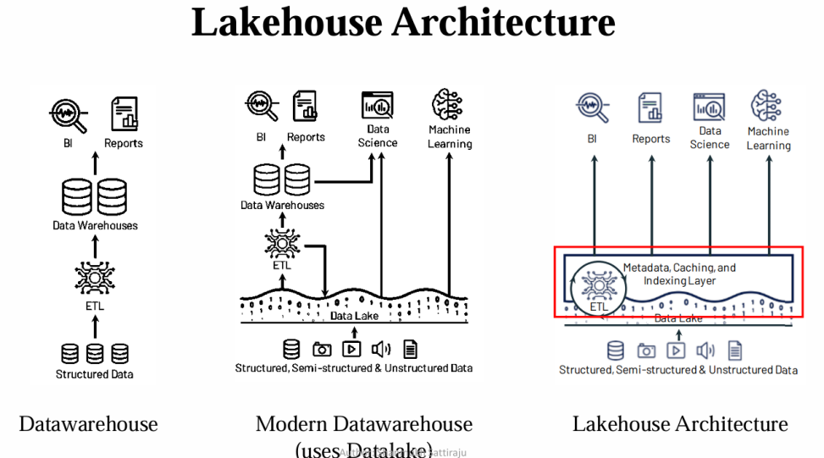

**So Databricks has solved this by using Delta Lake. They introduced metadata, which is transaction logs on top of the data lake, which gives us data warehouse like features.**

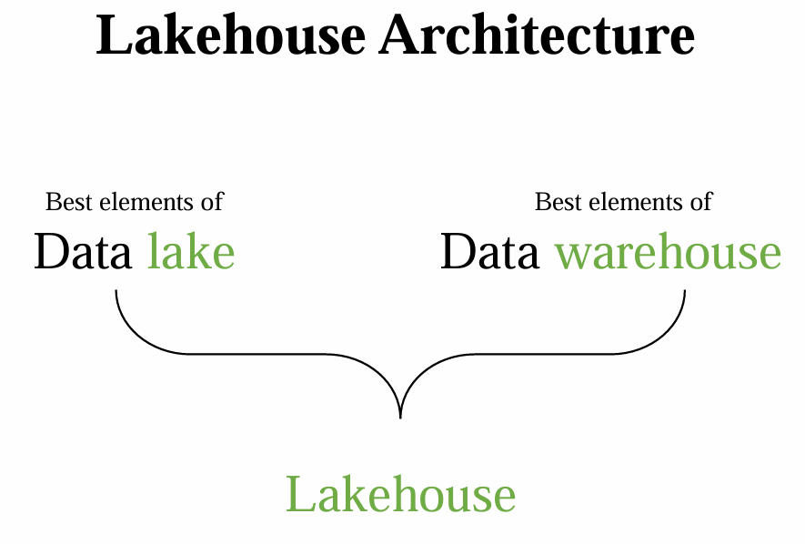

**So Delta Lake is one of the implementation that uses the Lakehouse architecture. If you can see in the diagram there is something called metadata caching and indexing layer. So under the hood there will be data lake on the top of the data lake. We are implementing some transaction log feature where that is called the Delta lake, which we will use the Delta Lake to implement Lakehouse architecture.**

**So let's understand about the Lakehouse architecture now. So the combination of best of data warehouses and the data lakes gives the Lakehouse where the Lakehouse architecture is giving the best capabilities of both.**

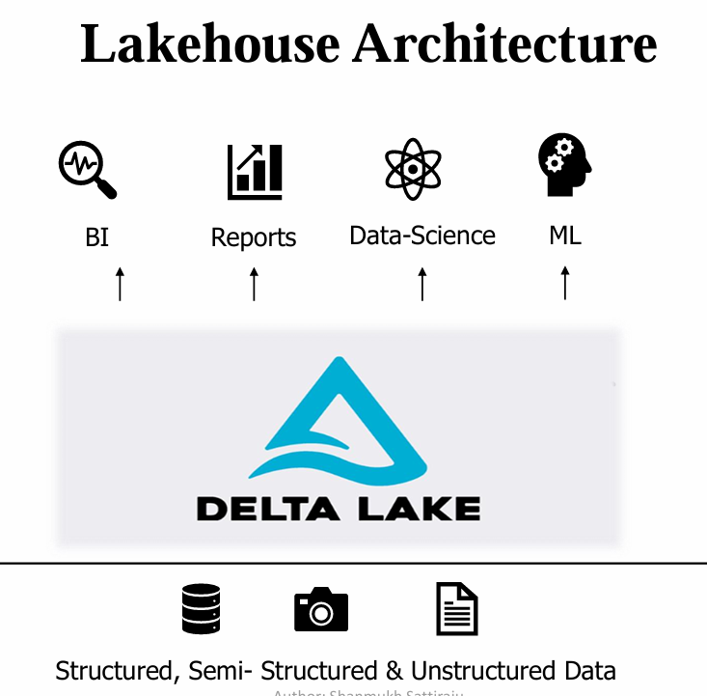

**If you can see the diagram, Data Lake itself will be having an additional metadata layer for data management, which having a transaction logs that gives the capability of data warehouse.**



**So using Delta Lake we can build this architecture. So let's see more about the Lakehouse architecture now. So coming to this we have the data lake and data warehouse which are architecture we have seen. And each is having their own capabilities.**

**Now Data Lake House is built by best features of both. Now we can see there are some best elements of Data Lake and there are best elements of Data Warehouse. Lake House also provides traditional analytical DBMs management and performance features such as Acid transaction versioning, auditing, indexing, caching, and query optimization.**

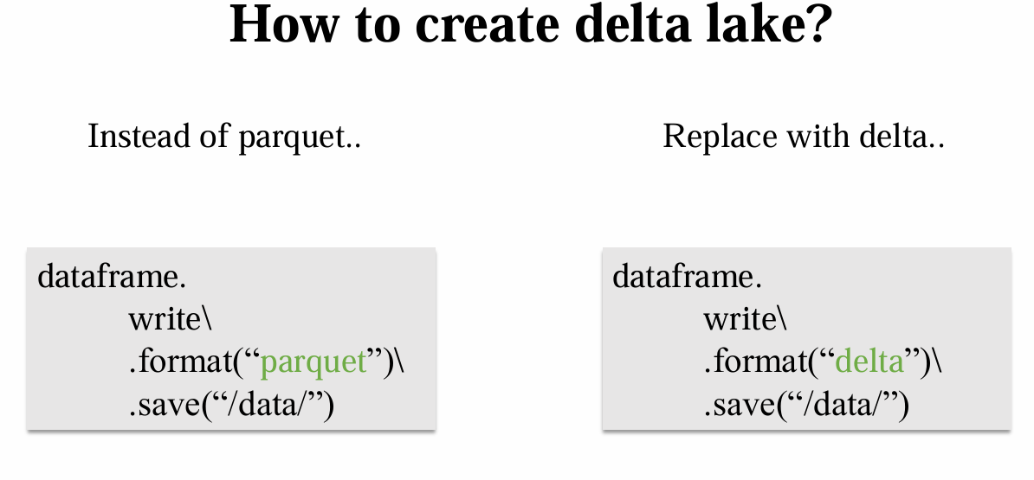

**Create Databricks instances (with standard Workspace otherwise Delta Live tables and SQL warehousing will be disabled) and ADLS Gen 2 instances in Azure Portal.**

**Hands-on: Accessing Datalake storage using service principal:**

**“Day 6 Part 1 Test+access.ipynb”**

**Source Link:** [Tutorial: Connect to Azure Data Lake Storage Gen2 - Azure Databricks | Microsoft Learn](https://learn.microsoft.com/en-us/azure/databricks/connect/storage/tutorial-azure-storage#--step-3-grant-the-service-principal-access-to-azure-data-lake-storage-gen2)

**Step 1: Create ADLS Gen 2 instance**

Inside ADLS Gen 2, create a ADLS Gen 2 with name “deltadbstg”, create a container with name “test”, inside this container add a directory with name “sample”, upload a csv file name “countires1.csv”.

**Step 2: Databricks instances and Compute resource**

**Inside Databricks instances: Create a compute resource with Policy: “Unrestricted”, “Single node”, uncheck “Use Photon Acceleration”, select least node type.**



**Go give permission, we have unity catalogue.**

**Step 3: Create a Microsoft Entra ID service principal**

* **Go to Azure Entra ID (previously Azure Active directory), inside it, going to create some service principle, click on “App Registration” on left hand side where you can create an app. Click on “New Registration”,**
* **Give name: “db-access”, leave other settings as it is. Copy “Application (client) ID” and “Directory (tenant) ID” from “db-access” overview.**
* **Eg: Application ID: dbf11b5d-9d81-4cc8-82f3-f14da29c8c98**
* **Directory (tenant) ID: 076af1d9-53a7-48e4-9c43-8ae1c16db3e2**

**Step 4: Create new New client secret and Copy Secret Key**

* **Inside app registration: Also copy secret key from left, “certificates & secrets” from left, click on “+ New client secret”, give “Description” as “dbsecret” and click on “Add”.**
* **Copy the “Value” from “dbsecret” now.**
* **Eg: Client Secret Value or service credential:“HnF8Q~braIA_bVu6IVtDXrvVYzm_YCncVouGtcb.”**
* **Note three keys “Application (client) ID” and “Directory (tenant) ID” and “Value” from “dbsecret” i.e. secret ID in a text notebook.**
* **Inside notebook, secret ID is “service credential”.**



**Step 5: Add Role Assignment from Access Control (IAM)**

* **To give access to data storage, goto ADLS Gen 2 instances in Azure Portal, go to “Access Control (IAM)”, click on “+Add”, click on “+Add Role Assignment”, “User, Group and service Principal”-> search for “Storage Blob Data Contributor”, click on storage blob contributor” and “+select members”, type service principle which is “db-access”. Select, finally Review and Assign.**

**Step 6: Put all these credentials at respective places**

**Replace everything here:**

**----------------------------------------------**

**service_credential = dbutils.secrets.get(scope="<scope>",key="<service-credential-key>")**

**spark.conf.set("fs.azure.account.auth.type.<storage-account>.dfs.core.windows.net", "OAuth")**

**spark.conf.set("fs.azure.account.oauth.provider.type.<storage-account>.dfs.core.windows.net", "org.apache.hadoop.fs.azurebfs.oauth2.ClientCredsTokenProvider")**

**spark.conf.set("fs.azure.account.oauth2.client.id.<storage-account>.dfs.core.windows.net", "<application-id>")**

**spark.conf.set("fs.azure.account.oauth2.client.secret.<storage-account>.dfs.core.windows.net", service_credential)**

**spark.conf.set("fs.azure.account.oauth2.client.endpoint.<storage-account>.dfs.core.windows.net", "https://login.microsoftonline.com/<directory-id>/oauth2/token")**

**--------------------------------**

**Hands on 2: Drawbacks of ADLS – practical:**

**Day 6 Part 2 .+Drawbacks+of+ADLS.ipynb**

* **Create new directory in “test” container with name “files” and upload csv file “SchemaManagementDelta.csv”**

**This hands on showing that using data lake we are unable to perform Update operation. Only in delta lake this operation is supportive.**

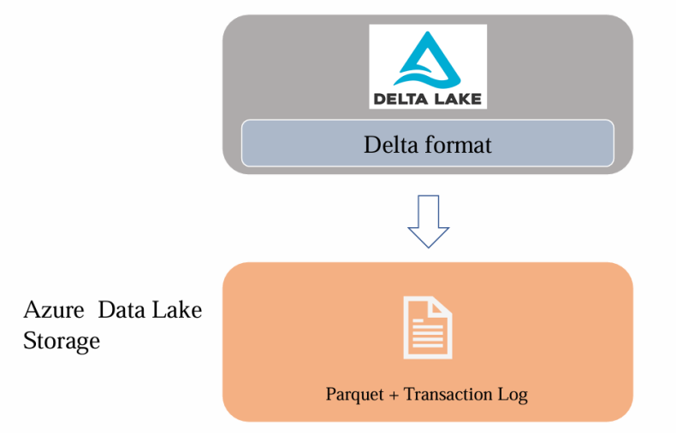

**Even using spark.sql, are unable to perform Update operation. This is one of Drawbacks of ADLS.**

**Versioning is also not available in ADLS, which is Drawbacks of ADLS.**

**Hands on 3: Creating Delta lake:**

**Day 6 Part 3 +Drawbacks+of+ADLS+-+delta.ipynb**

**Hands on 4: Understanding Transaction Log:**

**Day 6 Part 4 Understanding+the+transaction+log.ipynb**

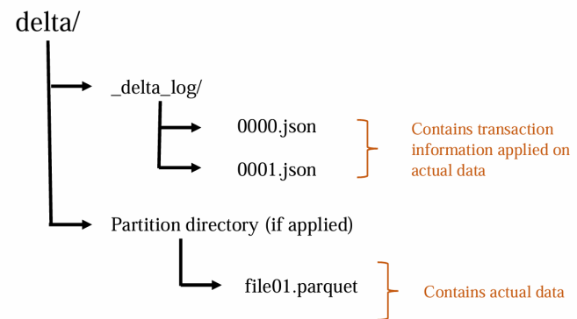

**Transaction logs tracks changes to delta table and it is responsible for bringing the ACID compliance for Delta lake.**

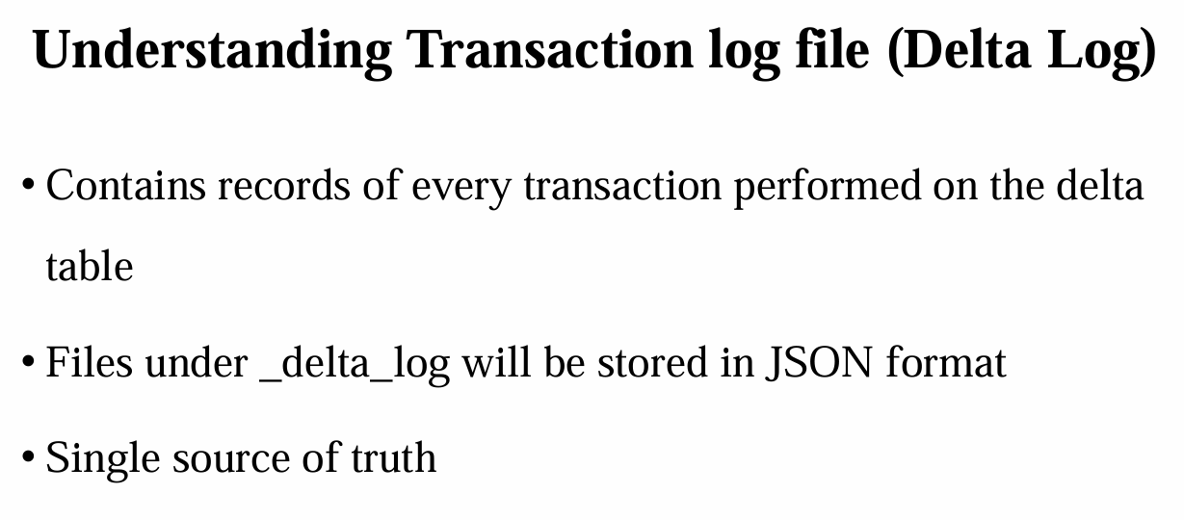

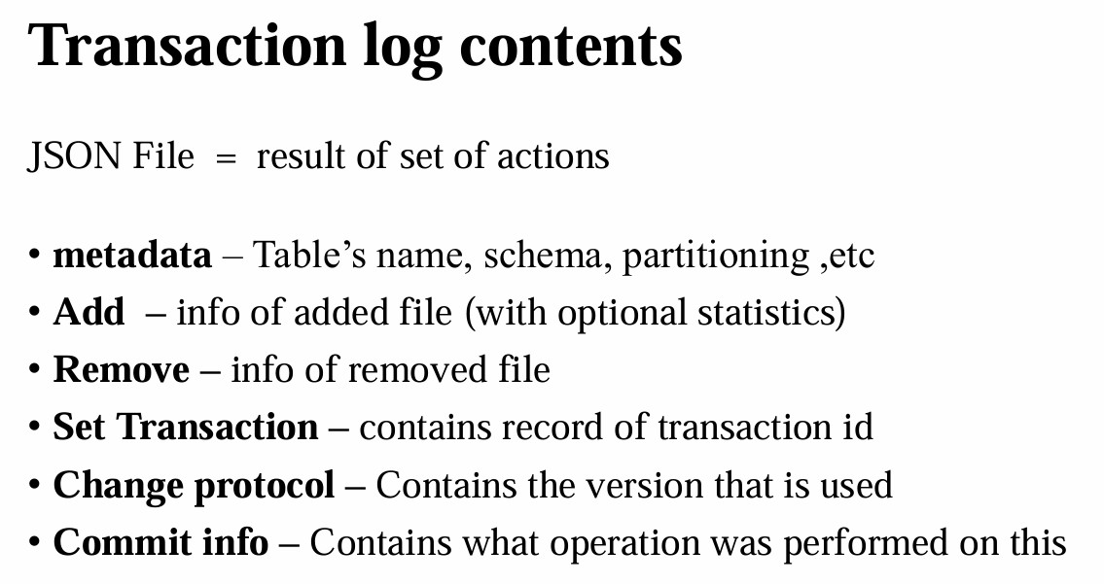

# Day 7: Creating delta tables using SQL Command

**Day 07 Part 1 pynb**

* **Change default language to “SQL”, then Create schema with name “delta”, before further code, where exactly we can see this table, go to “Catalog”, there are two defaults catalogues, “Hive metastore” and “samples”. This is not “Unity catalog”.**
* **The Hive metastore is a workspace-level object. Permissions defined within the hive_metastore catalog always refer to the local users and groups in the workspace. Hence Unity catalog cannot manage the local hive_metastore objects like other objects. For more refer** [**https://docs.databricks.com/en/data-governance/unity-catalog/hive-metastore.html#access-control-in-unity-catalog-and-the-hive-metastore**](https://docs.databricks.com/en/data-governance/unity-catalog/hive-metastore.html#access-control-in-unity-catalog-and-the-hive-metastore)**.**
* **Schema with name “delta” is created in “Hive metastore” catalogue, this is schema not database.**
* **Create table with name “’delta’.deltaFile” , any table which you are creating be default is a delta table in Databricks. Check again Schema with name “delta” which is created in “Hive metastore” catalogue, here one symbol with delta is also showing.**
* **To find exact location of this delta table: Go to “Cataloge”-> “Hive metastore” -> “delta” -> “deltaFile”-> “Details”-> “Location”.**
* **There is no parquet file, means we haven’t inserted any data.**

**Day 07 Part 2 pynb file**



**Day 07 Part 3 pynb file**

**Day 07 Part 4 pynb file**

* **Create “SchemaEvol” in “Test” containers (this is part of Day 6), before running this file upload two csv files, “SchemaLessCols.csv” and “SchemaMoreCols.csv” in “SchemaEvol” directory in “Test”.**
* **Schema Enforcement or Schema Validation: Let’s take a delta table, which is maintained strictly, we are ingesting data into this table on daily basis. In one ingestion, if a new data is coming with new “Column” which is not available in this schema.**

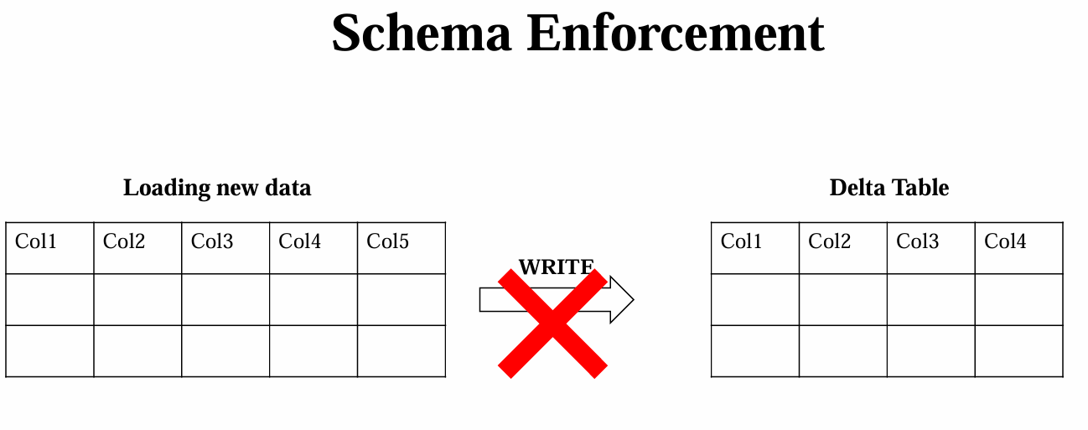

* **Delta Lake uses Schema validation on “Writes”.**
* **Now on a fine day during the data ingestion some data comes with a new column which is not in the schema of our current table, which is being overwritten to the location where our delta lake is present.**

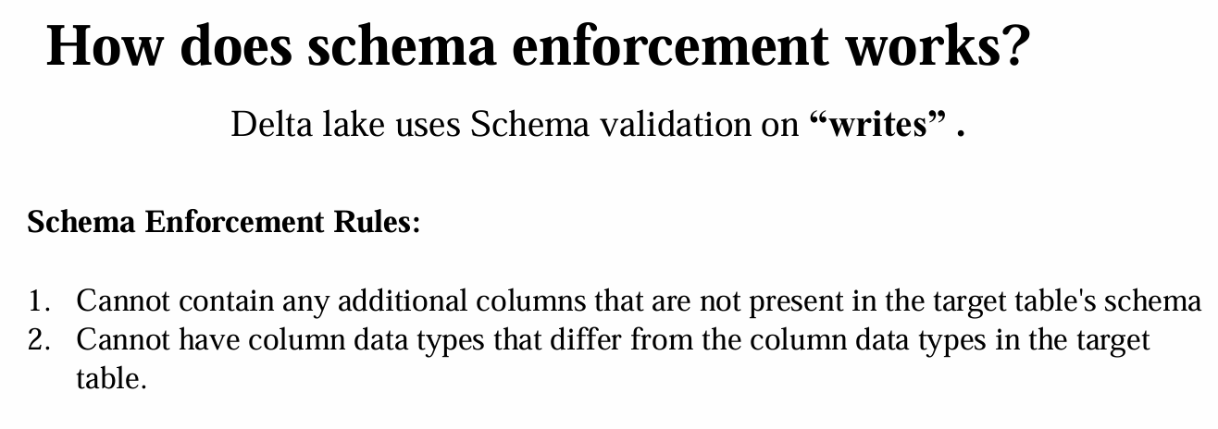

* **Now, generally, if you are using the data lake and I'm mentioning it again to prevent any confusion, I mean the data lake, not the delta lake, the general data lake will allow the overwriting of this data and we will lose any of our original schema.**
* **Like we have seen in the drawback, we try to overwrite to the location where we lost our data and it allowed the write.**



* **But coming to the Delta Lake, we have a feature called schema enforcement or Schema validation, which will check for the schema for whatever the data that is getting written on the Delta Lake table.**
* **If the schema does not match with the data which we are trying to write to the destination, it is going to reject that particular data.**
* **It will cancel the entire write operation and generates an error stating that the schema is not matching the module of the schema.**
* **Validation is to safeguard the delta lake that ensures the data quality by rejecting the writes to a table that do not match the table schema.**
* **A classic example is you will be asked to scan your IDs before entering your company premises, so that is going to check if you are the authorized person to enter this.**
* **Similarly, schema enforcement acts as a gatekeeper who checks for the right data to enter to the Delta Lake.**
* **Now, how does this schema enforcement works exactly?**
* **So to understand this, Delta Lake uses the schema validation on writes, which means all the new writes to the new table are checked for the compatibility with the target table.**
* **So during the right time it is going to check for the schema compatible or not.**
* **If the schema is not compatible, data is going to cancel. The delta lake cancels the transaction altogether.**



* **No data is being written, and it raises an exception to let the user know about the mismatch. And there are certain rules on how the schema enforcement works.**
* **And let us see on what conditions the incoming data will be restricted in writing to the delta table. So let's see about the rules now.**
* **So it cannot contain any additional columns like we have seen before.**
* **If the incoming data is having a column more than the one defined in the schema, it is treated as a violation to the schema enforcement.**
* **But if it is having less number of columns than the target table, it is going to allow the write by giving the null value to the existing columns where there is no data for this particular table.**
* **But if the incoming data is having more number of columns, it is going to cancel that insert.**

**Now there is one more rule where it cannot have the different data types. If a delta table's column contains the string data, but the corresponding column in the data frame incoming is having the integer data, the schema enforcement will raise an exception and it will prevent the write operation entirely.**

* **Now how is this schema enforcement useful?**
* **Because it is such a stringent check, schema enforcement is an excellent tool to use as a gatekeeper to get a clean, fully transformed data set that is ready to use for production or consumption.**
* **It is typically enforced on tables that directly fed into the machine learning algorithm by dashboard or data analytics or visualization tools, and schema enforcement is used for any production system that is requiring highly structured, strongly typed semantics checks.**
* **And it's enough with this theory.**
* **Trying to append more columns using code. Extra column is “Max_Salary_USD”.**
* **Source with fewer columns will accept.**



**Day 07 Part 5 pynb file**

* **Schema Evolution: Schema evolution in Databricks Delta Lake enables the flexible evolution of table schemas, allowing changes such as adding, removing, or modifying columns without the need for rewriting the entire table. This flexibility is beneficial for managing changes in data structures over time.**

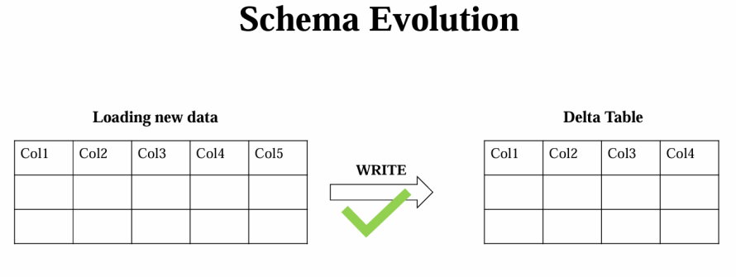

* **So schema evolution is a feature that allows the user to easily change the tables current schema to accommodate the data changing over time.**
* **Most commonly, it is used when performing an append or an override operation to automatically adapt the schema to include one or more columns.**
* **“mergeSchema”,”True” enables this Schema Evolution in Delta tables.**

**Day 07 Part 6 pynb file**

**Audit Data changes & Time Travel: "Time travel" in Delta Lake enables users to query a historical snapshot of the data at a specific version, facilitating data correction or analysis at different points in time.**

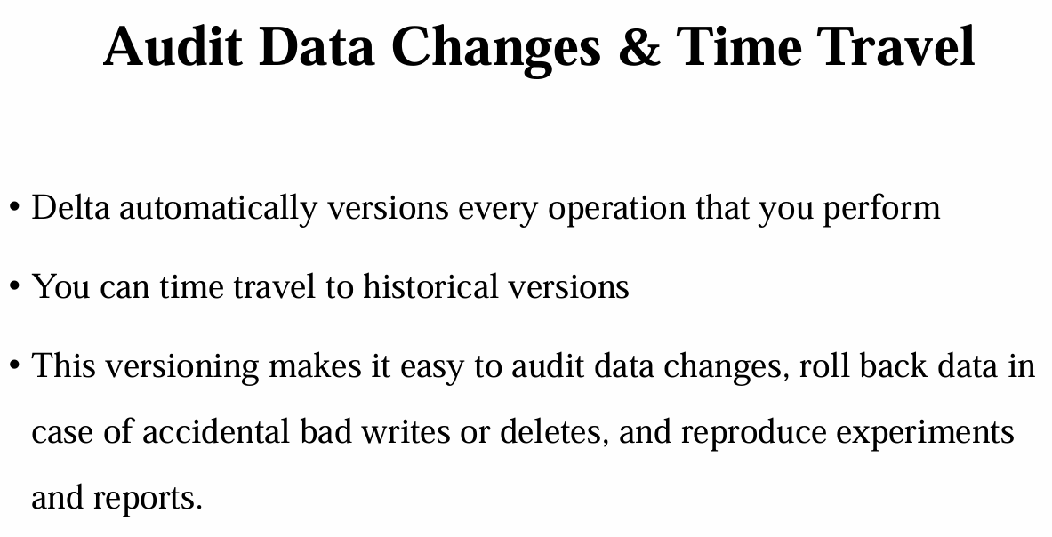



**Day 07 Part 7 pynb file**

* **Vacuum Command:**
* **If you are getting a very high storage cost now, if your organization wish to delete the old data like a 30 days old data, you can make use of the vacuum command.**
* **Now let's see how we can implement this. Now in order to know how many files will be deleted, you can make use of the dry run feature in the vacuum.**

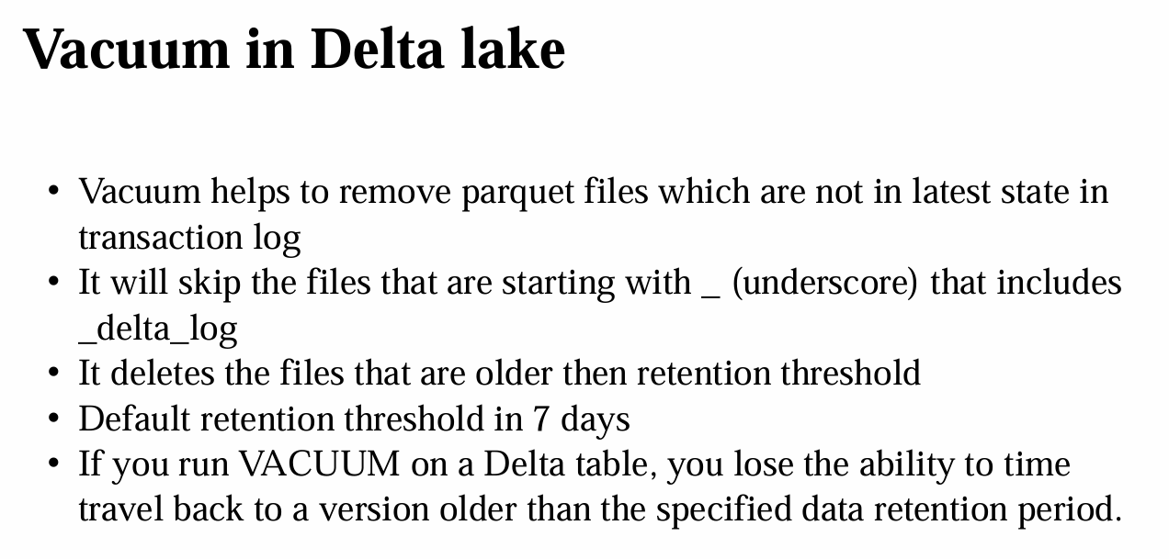

* **So let's see how you can implement this. Now I am going to use some feature called dry Run.**
* **So it is not actually going to delete any kind of data. It is just going to show us how many files will be deleted. So it will ideally give a list of first thousand files that will be deleted and it will not actually delete.**
* **It will just show what files will be deleted. Now, by default, the retention period of this vacuum command is seven days. So any data that is having the age of more than seven days that will be deleted by default using this vacuum command.**
* **So we just created our table and we just inserted few records, but we haven't have any data which is older than seven days.**
* **Now, if I just try to run this particular command, it is going to show me nothing. And now you can see he's not returning any results because we are not having any data, which is post seven days old, which is the retention period of this particular vacuum command.**



* **Now for testing purpose, if you want to delete the data, which is less than seven period of time than the default duration, you can make use of the retain command.**
* **There is restriction, just make “retentionDuration” to True.**

**Day 07 Part 8 pynb file**

**Convert to Delta:**

# 

# Day 8: Understanding Optimize Command – Demo

* **Optimize command in Databricks primarily reduces the number of small files and compacts data, improving query performance and storage efficiency.**
* **So on a high level, the optimize command will help us to compact multiple small files into a single file.**

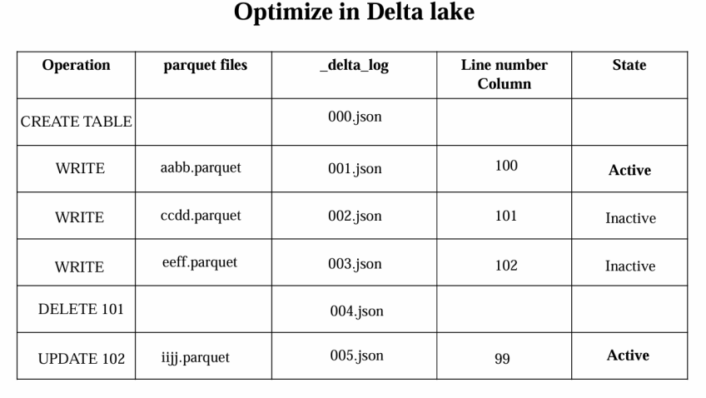

* **So this is one of the optimization feature in the delta lake which the name itself indicates the optimize. Now the use of this particular command is to compact multiple files into a single file.**
* **If you are aware of the small file problem in the spark, where if you have 100 small files, where each transaction is creating a file, if you want to read the content of each and every file, the time to open each and every file is more than reading the actual file.**
* **It need to open the file, it need to read the content, and it need to close the file. So the time to open and close each and every file is more than actual content reading. So this is why the optimize command helps in a way where it can just combine all the active files into a single file.**
* **I am mentioning something like active files, because sometimes there are inactive files where. Let us try to understand what exactly is this active and what is an inactive.**
* **So let's see by taking an example. So we'll be doing some transformations on our data in our Delta lake transformations are nothing but the operations like inserts, deletes and updates and etc..**
* **So each action or a transformation will be treated as a commit and it will create the parquet file.**

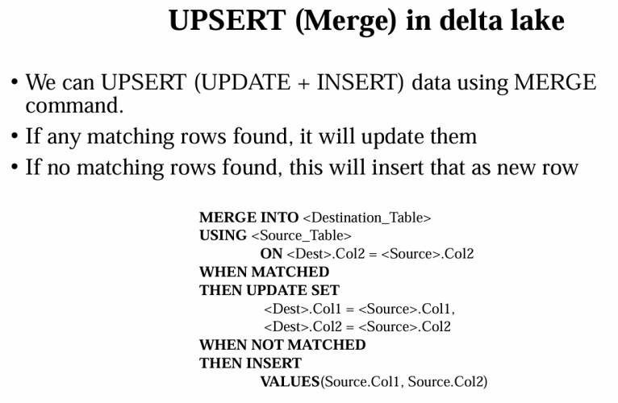

* **Along with that it will create the delta log files. So imagine we are creating a empty table because we are doing an empty table creation. It is also an operation where the operation is recorded as a create table.**
* **And it is not going to create any parquet file, but it is going to create a delta log.**



# Day 9: What is Unity Catalog: Managed and External Tables in Unity Catalog

### ****Understanding the Problem Unity Catalog Solves****

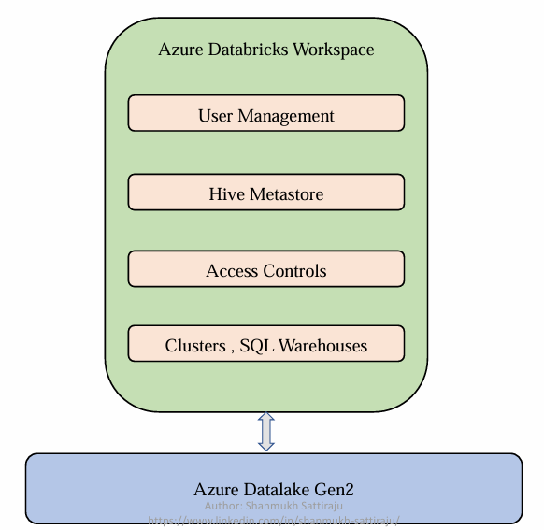 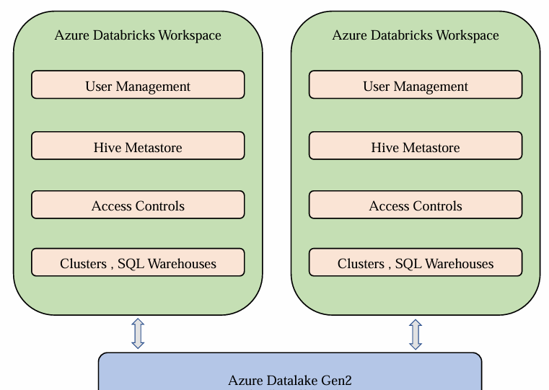

**Unity Catalog:** bringing order to the chaos of the cloud. It is a data governance tool that provides a centralized way to manage data and AI assets across platforms.

**Unity Catalog:** a powerful tool designed to centralize and streamline data management within Databricks.

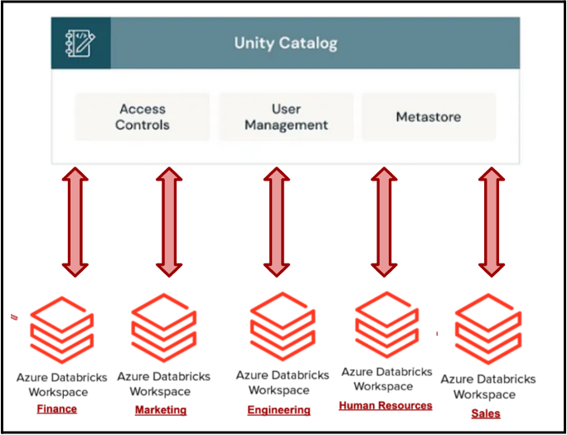

**Unity Catalog** centralizes all metadata, ensuring that user data definitions are standardized across the organization. This means that the marketing, customer service, and product development teams all have access to a single, consistent source of truth for user data. By providing a unified view of all data assets, **Unity Catalog** makes it easier for teams to access the information they need without having to navigate through multiple systems.

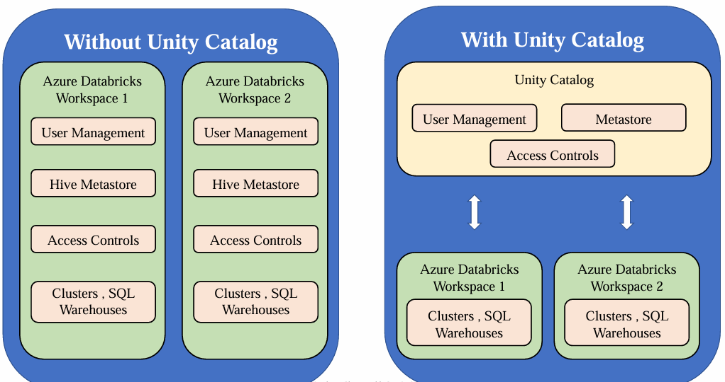

The marketing team can easily access support interaction data, and the product development team can view user engagement metrics, all from a single platform. This unified approach reduces administrative overhead, enhances data security, and ensures that data is accurate and compliant, supporting better data-driven decision-making and driving business success.

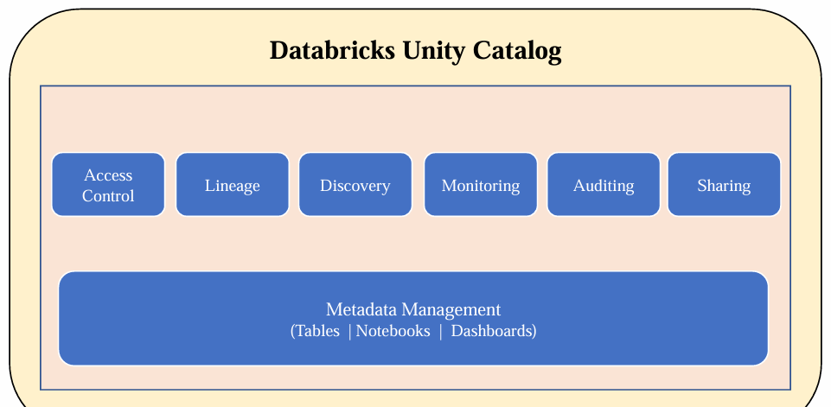

1. **Typical Databricks Setup**
   * Organizations use Databricks workspaces for projects (e.g., Azure Databricks).
   * User management is required for assigning roles (developers, leads, managers).
   * Each workspace has a Hive metastore storing managed tables and defined access controls.

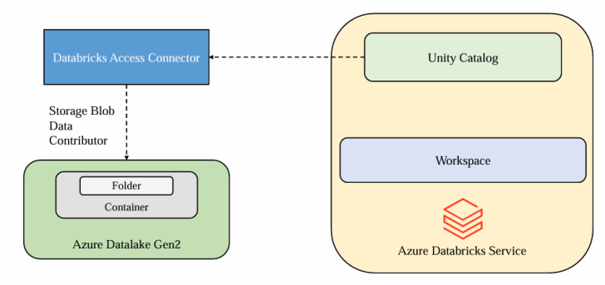

1. **Challenges in Managing Multiple Workspaces**
   * Multiple environments (dev, UAT, prod) and business units/projects require several workspaces.
   * Duplication of user management, access controls, and cluster creation policies across workspaces.
   * Lack of centralized governance for managing users, auditing, and metadata.
   * Difficult to track who has access to specific data across all workspaces.
2. **Need for a Centralized Solution**
   * A central system for governance, audit, and metadata management is required.
   * 

### ****How Unity Catalog Solves the Problem****

1. **Centralized Governance**
   * Manages user access, metadata, and governance for multiple workspaces centrally.
   * Provides visibility and control over access permissions across all workspaces.
2. **Unified Features**
   * **Access Controls**: Define and enforce who can access what data.
   * **Lineage**: Track how data tables were created and used.
   * **Discovery**: Search for objects like tables, notebooks, and ML models.
   * **Monitoring**: Observe and audit object-level activities.
   * **Delta Sharing**: Share data securely with other systems or users.
   * **Metadata Management**: Centralized management of tables, models, dashboards, and more.



### ****Summary****

Unity Catalog is a centralized governance layer in Databricks that simplifies user and metadata management across multiple workspaces. It enables unified access control, data lineage, discovery, monitoring, auditing, and sharing, ensuring seamless management and governance in one place.

**Hands-on:**

**Step 1: In Azure Portal, create a Databricks workspace and ADLS Gen2, add these two Databricks workspace and ADLS Gen2 in “Favorite” section.**

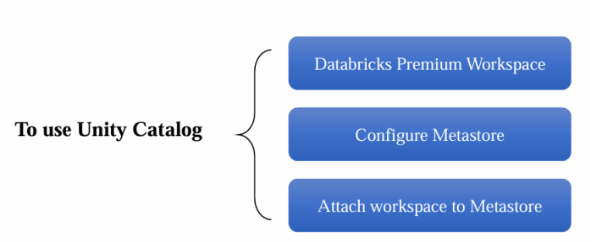



**Step 2: search for “Access connectors for Azure Databricks”, create “New”, only give resource group name and Instance name “access-connectors-sachin” here, you need not to change anything here. Click on “Go to Resource”. Now in “Overview”, “Resource ID”, can use this “Resource ID” while creating the Metastore.**



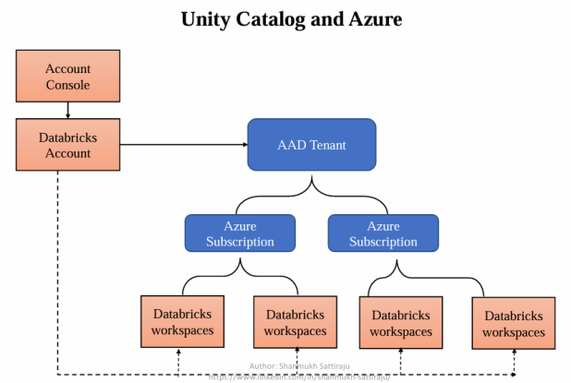

**Step 3: Create ADLS Gen2, “deltadbstg”-> “test”-> “files”->”SchemaManagementDelta.csv”. Now give access of this Access connectors to ADLS Gen2, go to ADLS Gen2, go to “Access Control IAM” from left pane, click on “Add”-> “Add Role Assignment”-> search for “Storage Blob Data Contributor”, in “Members”, select “Assign Access to”->”Managed Identity” radio button, “+Select Members”-> select “Access connectors for Azure Databricks” under “Managed identity” drop down menu-> “Select”-> “access-connectors-sachin” -> “Review+Assign”.**

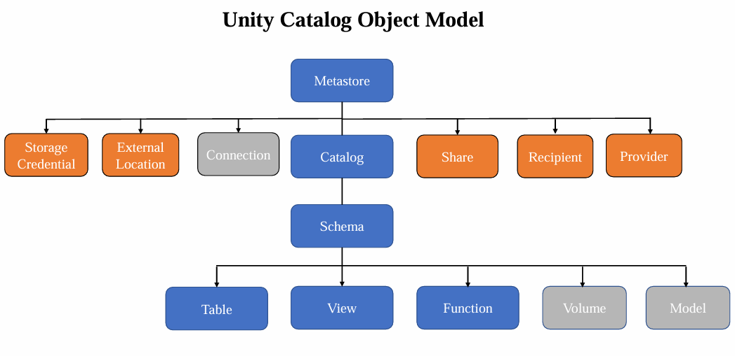

* **Now using this managed identity, our Unity catalog or Metastore can access this particular storage account. And the reason why we are doing is we need to have a container where that is going to be accessed by the unity catalog to store its managed tables, and we will see that in upcoming lectures.**



**Step 4: To use Unity Catalog: following are pre-requisites:**

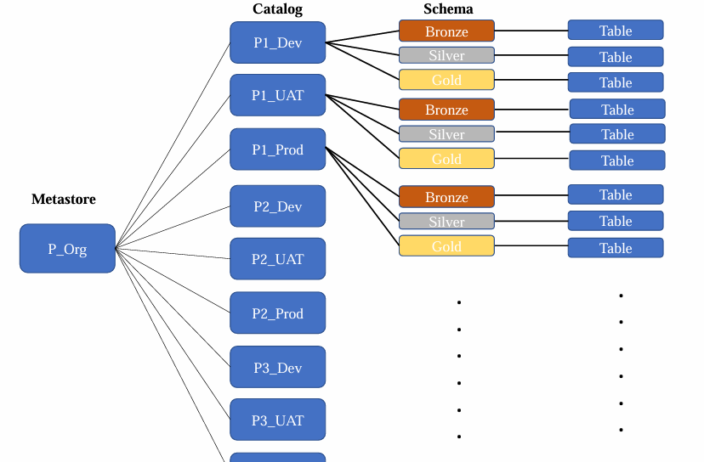

1. **Must have Databricks Premium Workspace**
2. **Configure Metastore (Done in Step 3)**
3. **Attach premium workspace to Metastore**
4. **Note:** [**https://accounts.azuredatabricks.net/**](https://accounts.azuredatabricks.net/) **, in case you are not able to access "Manage Account" setting in my Azure Portal, click here:**
5. **a.** [**https://learn.microsoft.com/en-us/answers/questions/1843839/not-able-to-access-manage-account-setting-in-my-az**](https://learn.microsoft.com/en-us/answers/questions/1843839/not-able-to-access-manage-account-setting-in-my-az)
6. **b.** [**https://learn.microsoft.com/en-us/answers/questions/1344479/unable-to-login-accounts-azuredatabricks-net-and-c**](https://learn.microsoft.com/en-us/answers/questions/1344479/unable-to-login-accounts-azuredatabricks-net-and-c)
7. **c.** [**https://learn.microsoft.com/en-us/azure/databricks/admin/#account-admins**](https://learn.microsoft.com/en-us/azure/databricks/admin/#account-admins)

**Now go to Databricks, we need to start a creating a meta store, meta store is top level container in the unity catalog, go “Manage Account” under “Sachindatabricks name” from right top -> “Catalog” from left pane, “create meta store”, provide “Name” as “metastore-sachin”,”Region”(can create one meta store in single region), “ADLS Gen2 path” (go to ADLS Gen2-> create container-> “Add Directory”, paste <container_name>@<storage_account_name>.dfs.core.windows.net/<directory_Name>**

**Or test@deltadbstg123456.dfs.core.windows.net/files), “Access connector ID” (go to “Access connectors”-> “access-connectors-sachin” -> copy that “resource ID”)-> “Create”.**

**Attach with any workspaces. “Enable Unity Catalog?”-> “Enable”.**



**Step 5: Create the required users to simulate the real time environment: go to “Microsoft Entra ID”-> “Add”-> “users” from left pane-> “new user”-> “create new user”-> give any name to “User Principal Name”-> give any display Name “Sachin_Admin” ->give custom password not “Auto generate password”-> not required to change any “Properties”, “Assignments”-> click on “Create”.**

* **Now login from** [**https://accounts.azuredatabricks.net/**](https://accounts.azuredatabricks.net/) **using username and password from Step 5. Using unity catalog, we can access to this user. My username is : sa******xgmail.onmicrosoft.com and password is K***r3**#**



**Step 6: Create one more user as in Step 5, now we two new users.**

* **So these are two new users we have created for this session, where we will try to simulate the real time environment by giving them required access to understand the roles and responsibilities clearly, because user management is something, if you are in a project, generally there will be an admin who can do this, but in real times they will expect you to handle this by your own. A data engineer must also be aware who can access what.**
* **First user will be Workspace admin and second will be developer.**



**Step 7: Now in Databricks portal, click on “Manage Account”, from right top, this Databricks portal is created neither by Workspace admin nor developer, in order to add user, click on “User Management” from left pane, we need to add both Workspace admin and developer.**

* **Click on “Add User”-> paste email id from “Microsoft Entra ID” -> “User Principal name”, can give any “first name” and “last name” as “Workspace admin”. Now add developer “User Principal name” in same way.**
* **Click on “Setting” from left, -> “User Provisioning”-> “Set up user provisioning”.**
* **Open a “incognito window” mode to open** <https://portal.azure.com/#home> with “admin Sachin” and “Developer Sachin” both, it will ask to create new password.



**Step 8: to create group, click on “Manage Account”, from right top, this Databricks portal is created neither by Workspace admin nor developer, in order to add user, click on “User Management” from left pane-> “Groups” -> “Add Group”, we are going to create two groups, first group is “Workspace Admins”-> “Add Members” from admin only and second group is “Developer team”-> “Add Members” of developer only.**

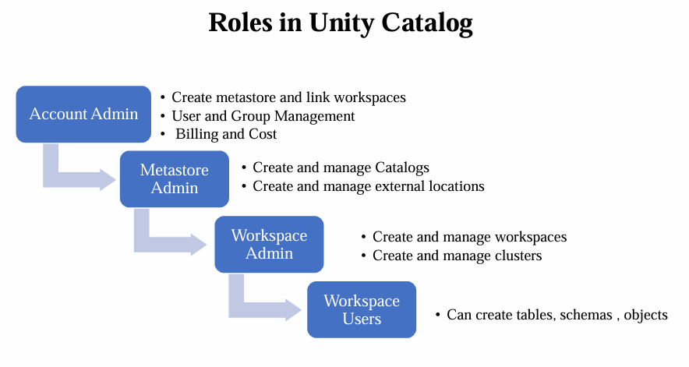



**Step 9: It’s time to give permission, in Databricks portal, click on “Manage Account”, from right top, this Databricks portal is created neither by Workspace admin nor developer, in order to give permission, click on “Workspaces”, click on respective “Workspace” -> inside it “permissions”-> “Add Permissions”-> we need to add groups which we created in Step 8, to admin group assign “Permission” as “Admin” and to developer group assign “Permission” as “User”.**

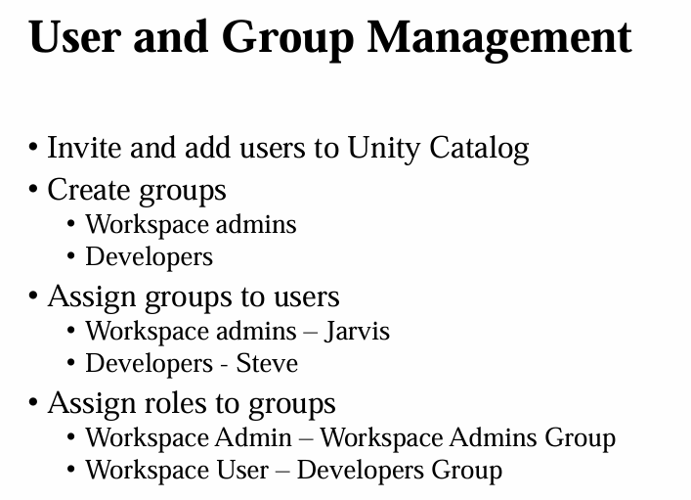



**Step 10: Now login from** [**https://portal.azure.com/signin/index/**](https://portal.azure.com/signin/index/) **using username and password, need to paste databricks workspace go to Databricks portal, click on “Manage Account”, from right top, this Databricks portal is created neither by Workspace admin nor developer, go to Azure portal from main where we created first Databricks workspace, copy “Workspace URL” ending with xxx.azuredatabricks.net.**

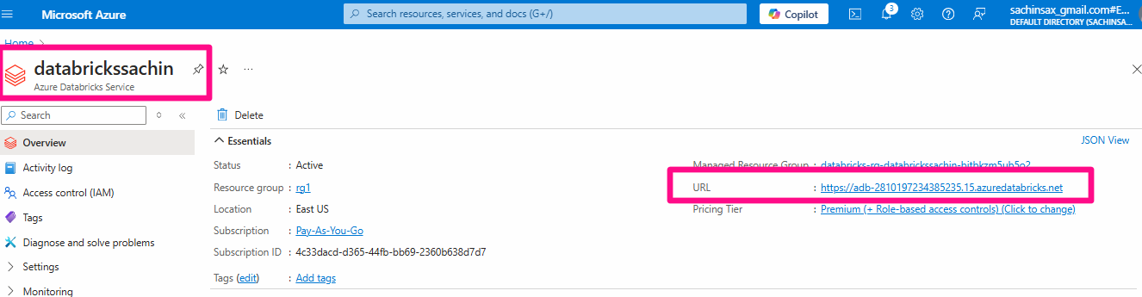

**Sign in with admin credentials, in similar way, go to Azure portal from main where we created first Databricks workspace, copy “Workspace URL” ending with xxx.azuredatabricks.net and sign in with user credentials.**

* **Just check that in developer portal, we do not have “Manage Account” setting, also in developer portal cannot see any compute resources in “Compute” tab.**



**Step 11: Create Cluster Policies: login with admin and move to databricks portal from this “sachin admin” login, go to “admin setting” from right top.**

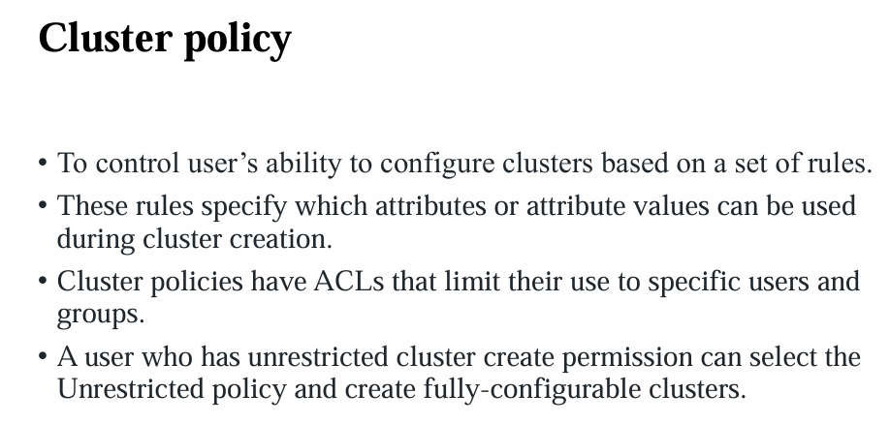

* **Click on “Identity and access” from second left pane. Click on “Manage” from “Management and Permissions” in “Users”. Click on “Kumar Developer” right three dots, click on “Entitlements”, check on “Unrestricted cluster creation”, “Confirm” it.**
* **Now check “Compute” tab of “Kumar Developer” in databricks portal that, this “create compute ” resource is now enabled.**
* **We do not want to give all kind of “Compute” resources to “Kumar Developer”, so we can restrict by using create policies, otherwise,** it will result in a significantly high bill, subsequently, **and it may incur a substantial expense.**
* **(This step is for disable Compute Resource in developer portal )To create policies, click on “Kumar Developer” right three dots, click on “Entitlements”, check off “Unrestricted cluster creation”, “Confirm” it. Now check “Compute” tab of “Kumar Developer” in databricks portal that, this “create compute” resource is now disabled again.**

# Compute policy reference: https://learn.microsoft.com/en-us/azure/databricks/admin/clusters/policy-definition

* **Jump to “”Sachin Admin” databricks portal, click on “compute”, click on “Policies”: click on “create policy”-> give “Name” as “Sachin Project Default Policy” , select “Family” as “custom”->**

**Change the following code:**

**{**

**"node_type_id": {**

**"type": "allowlist",**

**"values": [**

**"Standard_DS3_v2"**

**]**

**},**

**"spark_version": {**

**"type": "fixed",**

**"value": "13.3.x-scala2.12"**

**},**

**"runtime_engine": {**

**"type": "fixed",**

**"value": "STANDARD",**

**"hidden": true**

**},**

**"num_workers": {**

**"type": "fixed",**

**"value": 0,**

**"hidden": true**

**},**

**"data_security_mode": {**

**"type": "fixed",**

**"value": "SINGLE_USER"**

**},**

**"cluster_type": {**

**"type": "fixed",**

**"value": "all-purpose"**

**},**

**"instance_pool_id": {**

**"type": "forbidden",**

**"hidden": true**

**},**

**"azure_attributes.availability": {**

**"type": "fixed",**

**"value": "ON_DEMAND_AZURE",**

**"hidden": true**

**},**

**"spark_conf.spark.databricks.cluster.profile": {**

**"type": "fixed",**

**"value": "singleNode",**

**"hidden": true**

**},**

**"autotermination_minutes": {**

**"type": "fixed",**

**"value": 20**

**}**

**}**

* **Click on “Permission” in ”Sachin Admin” databricks portal, click on “compute”, click on “Policies”: click on “create policy”-> give “Name” as “Sachin Project Default Policy”, in “Name”, select “Developers” -> “can use”, click on “Create” from right top.**

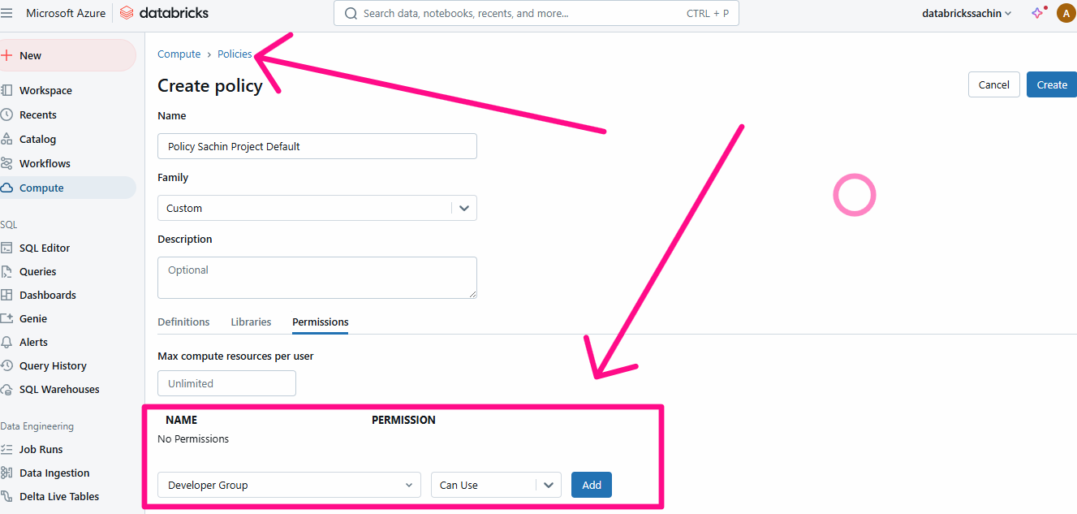

* **Now, if you jump to as “Sachin Developer” databricks portal, “Compute” tab, one “Sachin Project Default Policy” will appear at right top.**



### Step 12: Cluster Pools in Databricks:

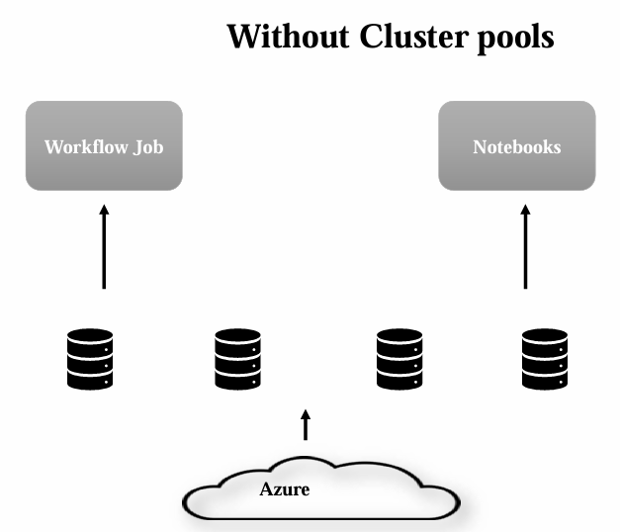 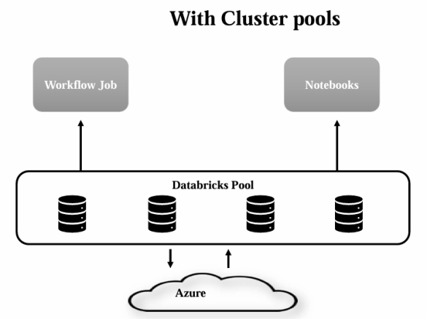

* **Purpose of Cluster Pools**:
  + Reduce cluster creation time for workflows or notebooks.
  + Enable ready-to-use compute resources in mission-critical scenarios.
* **Cluster Creation Process**:
  + Compute resources are required to run workflows or notebooks.
  + Creating a cluster involves requesting virtual machines (VMs) from a cloud service provider.
  + VM initialization takes ~3-5 minutes, which may not be ideal for real-time tasks.
* **Cluster Pool Functionality**:
  + Cluster pools pre-request VMs from the cloud provider based on configurations.
  + Keeps some VMs ready in a running or idle state.
  + Enables faster cluster creation by utilizing these pre-initialized VMs.
* **Performance and Cost Trade-Off**:
  + Performance improves as clusters are ready in reduced time (~half the usual time).
  + Databricks does not charge for idle instances not in use, but cloud provider infrastructure costs still apply.
* **Use Case**:
  + Ideal for workflows or notebooks needing rapid cluster creation.
  + Balances between cost and efficiency by keeping resources ready.
* **Key Takeaway**:
  + Cluster pools enhance performance by maintaining idle VMs for quick allocation, albeit with associated cloud costs.
* **Cluster Pools in Databricks Hands-on: Jump to “Sachin Admin” databricks portal, click on compute, go to “Pool”, click on “create pool”, name as “Available Pool Sachin Admin”, pool will already keep you instances in ready and running state so that we can use them while creating the cluster. And these will access the resources which are readily available.**
* **Also keep “Min Idle” as 1 and “Max Capacity” as 2. Now let me make the minimum idle instance to one and maximum two. This means all the time this one instance will be in ready and in running state. And in case if this one instance is used by any cluster, another will be in the Idle state because minimum one will be idle all the time, irrespective of the one is attached or not. So in maximum of two will be created. So one can be used by cluster and if that is already been occupied, another one will be in the idle state.**
* **Change “terminate instances above minimum tier” to 30 minutes of idle time.**
* **Change “Instance Type” to “Standard_DS3_v2”**
* **Change “On-demand/spot” to “All On-demand” radio button, bcs sometimes Spot instances are not available.**
* **Create it. It will take much time. Copy Pool ID from here.**
* **Now go to Edit Policies under “Policy tab” which was done in Step 11, make changes in:**

**},**

**"instance_pool_id": {**

**"type": "forbidden",**

**"hidden": true**

**},**

**To Get Pool ID here:**

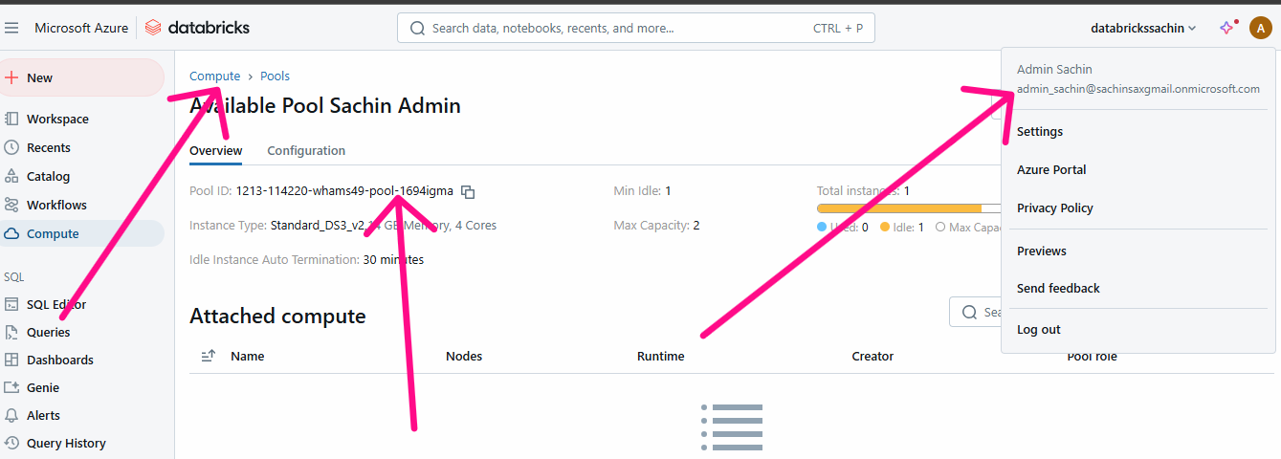

**"instance_pool_id": {**

**"type": "fixed",**

**"value": "1211-104550-gybed90-pool-ns7wqs2q<Your Pool ID>"**

* **Now go to Compute Tab in “Sachin Admin” databricks, click on “Pool”->select given “availavle Pool Sachin Admin” -> click on Permission-> select “Developers group” (not individual developer) to “Can Attach to”-> “+Add”, “Save” it.**



**Step 13: Creating a Dev Catalogs: go to “Sachin Admin” databricks portal, go to “Catalog” tab, but “Create Catalog” is disabled now because we haven’t define this permission, in order to give permission, go to “Main Datbricks” portal (neither Sachin Workspace admin nor Kumar developer), go to databricks portal, go to “Catalog” tab, “Catalog Explror” -> click on “Create Catalog” from right, name “Catalog name” as “DevCatalog”, type as “Standard”, skip “Storage location”. Click on “Create”.**



**Step 14: Unity Catalog Privileges:**

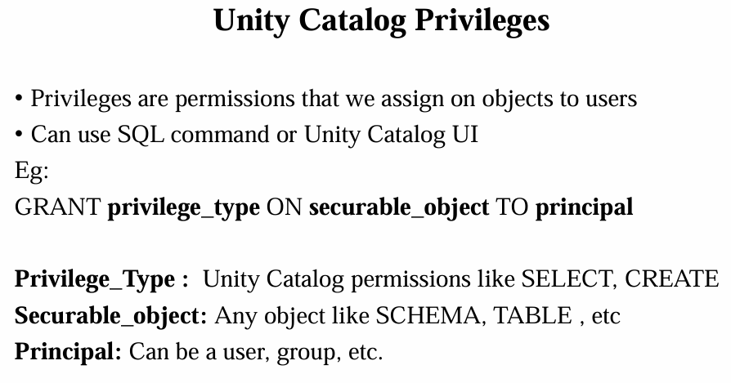

* **Go to “Sachin Admin” databricks portal, but still can’t see “Dev Catalog” because Sachin Admin and Kumar developer both are not having the required privileges or permission to use.**
* **Go to “Main Databricks” portal who is account admin (neither Sachin Workspace admin nor Kumar developer) go to “Catalog”, Click on “Dev Catalog”, then “Permissions”, then “Grant”, this screen is Unity catalog UI to grant privileges to “Sachin Admin”, then click on “Grant”, select group name “WorkSpace admins” checkbox on “create table”, “USE SCHEMA”, “Use Catalog” and “Select” in “Privileges presets”, do not check anything here. Click on “Grant”. Now, go to “Sachin Admin” databricks portal, “Dev Catalog” is showing here.**

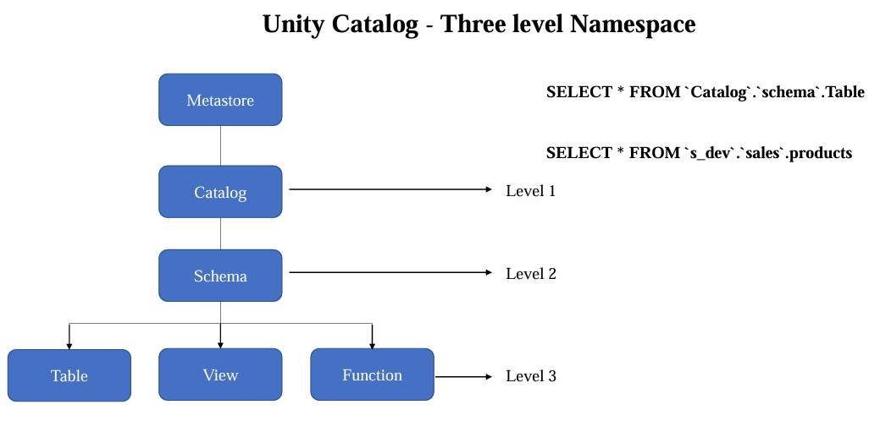

* **To transfer ownership of “Dev Catalog”, go to “Main Databricks” portal who is account admin (neither Sachin Workspace admin nor Kumar developer), go to “Catalog”, Click on “Dev Catalog”, click on pencil icon from mid top near Owner:** [**sacinsax@gmail.com**](mailto:sacinsax@gmail.com)**, “Set Owner for Dev Catalog”, change to “Workspace admins” not to specific user, bcs if one user leave the organization then it creates havoc situations.**
* **Now, go to “Sachin Admin” databricks portal, “Dev Catalog” is showing here.**
* **Now, go to “Sachin Admin” databricks portal, create a “notebook” here, to run any cell in this notebook, we need “Compute”, select “Create with Personal compute”, “Project Defaults”.**
* **Go to “Sachin Admin Databricks” portal go to “Catalog”, Click on “Dev Catalog”, then “Permissions”, then “Grant”, this screen is Unity catalog UI to grant privileges to “Sachin Admin”, then click on “Grant”, select group name “WorkSpace admins” checkbox on “Use Catalog”, “USE SCHEMA”, “Create Table” and “Select” in “Privileges presets”, do not check anything here.**
* **Now Run SQL command, file is saved in “Day 9” folder with name “Unity Catalog Privileges.sql”. in code GRANT USE_CATALOG ON CATALOG `devcatalog` TO `Developer Group`**



**Step 15: Creating and accessing External location and storage credentials:**

* **Step A: Go to “Sachin Admin Databricks” portal go to “Catalog”, we do not find any external data here, to find “External Data”, go to “Main Databricks” portal who is account admin (neither Sachin Workspace admin nor Kumar developer) go to “Catalog”, in “Catalog Explorer”, there is “External Data” below, click on “Storage Credentials”.**
* 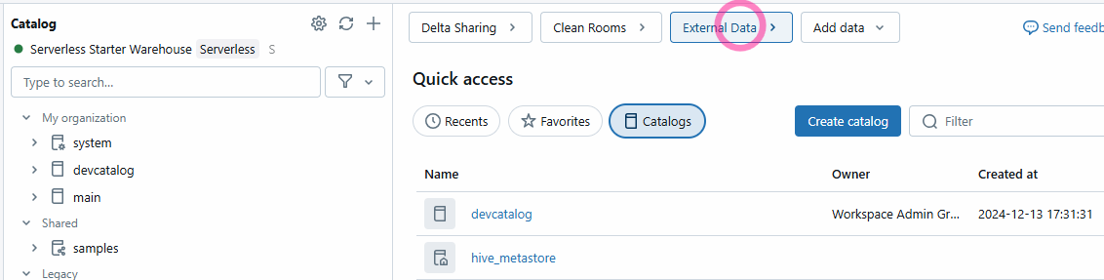
* 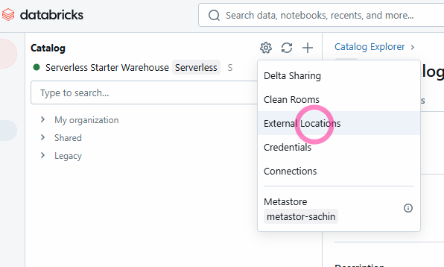
* **Step B: Now in ADLS Gen2, “deltadbstg”-> “test”-> “files”->”SchemaManagementDelta.csv”.**
* **Now give role assignment “Storage blob Data Contributor” to “db-access-connector” from IAM role in Azure Portal of Main admin.**

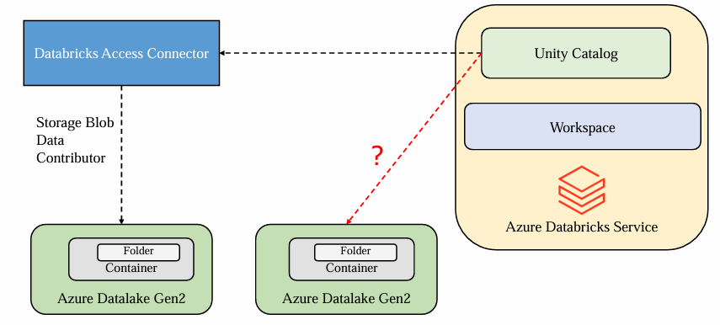

* **Step C: Now go to Step A Databrick portal, click on “create credential” under “External Data” below, click on “Storage Credentials”, “Storage Credentials Name” as “Deltastorage”, to get “Access connector Id”, go to “db-access-connector” from Azure Portal, will find “Resource ID”, copy this and paste to “Access connector Id”, click on “create”.**
* **Step D: Go to “Main Databricks” portal who is account admin (neither Sachin Workspace admin nor Kumar developer) go to “Catalog”, in “Catalog Explorer”, there is “External Data” below, click on “External Data”, click on ”Create external location” -> “Create a new external location”click on “External location name”: “DeltaStorageLocation”, in “Storage credential”, select “Deltastorage” which we created in Step C.**
* **To find URL: abfss://test@deltadbstg.dfs.core.windows.net/files (go to ADLS Gen2 “deltadbstg”-> “EndPoints”-> “Data Lake Storage” ), click on “create”.**
* **Click on “Test Connection”.**
* **Step E: create a notebook in “Main Databricks” portal who is account admin (neither Sachin Workspace admin nor Kumar developer), create a compute, create with “Unrestricted”, “Multi node”, create a Access mode “Shared” , uncheck “Use Photon Acceleration”, Min workers: 1, Max workers: 2.**
* **Run the following code in notebook in Main Databricks (Neither in Admin nor in Developer):**

%sql

CREATE TABLE `devcatalog`.`default`.Person_External

(

    Education_Level STRING,

    Line_Number INT,

    Employed INT,

    Unemployed INT,

    Industry STRING,

    Gender STRING,

    Date_Inserted STRING,

    dense_rank INT)

USING CSV

OPTIONS(

  'header' 'true'

)

LOCATION 'abfss://test3@deltadbstg.dfs.core.windows.net/dir'

* **Df=(spark.read.format(‘csv’).option(‘header’,’true’).load(‘abfss://test@deltadbstg.dfs.core.windows.net/files / ’))**
* **Display(Df)**



**Step 16: Managed and External Tables in Unity Catalog: Do hands on also.**

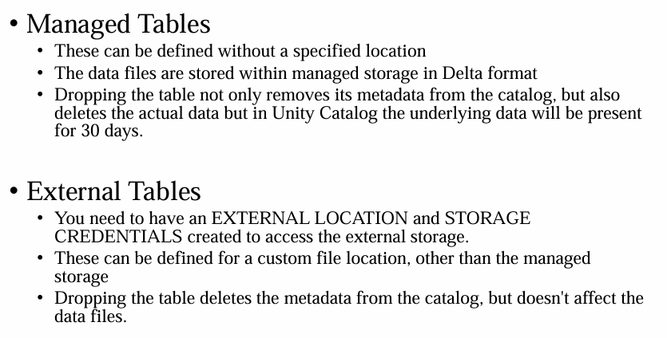

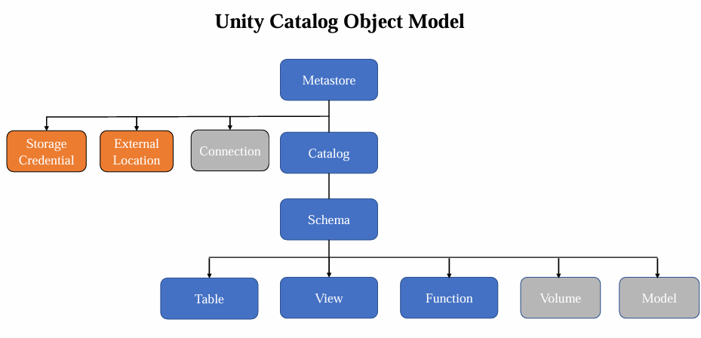

**Question: Which of the following is primary needed to create an external table in an Unity Catalog Enabled workspace?**

**Answer: You need an external location created primarily pointing out to that location , So you can get access to the path to create external table.**



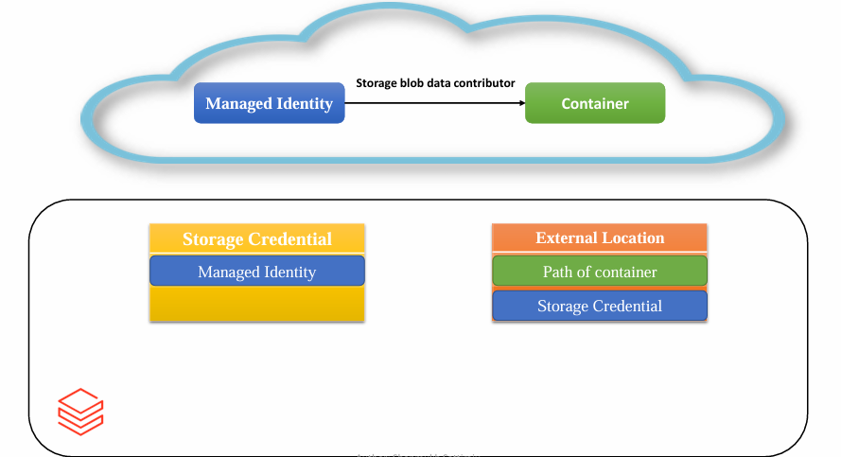

**Question: Can managed table use Delta, CSV, JSON, avro format?**

**Answer: No, Managed table can use only Delta format.**

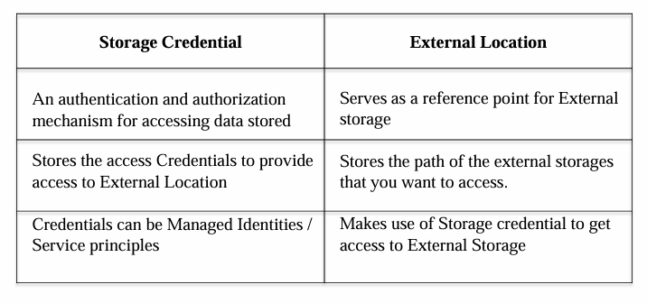



# Day 10: Spark Structured Streaming – basics

**Note: This hands on can be done on Databricks community addition, otherwise, it will result in a significantly high bill.**

**Definition: A data stream is an unbounded sequence of data arriving continuously. Streaming divides continuously flowing input data into discrete units for further processing. Stream processing is low latency processing and analyzing of streaming data.**

**Data ingestion can be done from many sources like Kafka, Apache Flume, Amazon Kinesis or TCP sockets and processing can be done using complex algorithms that are expressed with high-level functions like map, reduce, join and window. Finally, processed data can be pushed out to filesystems, databases and live dashboards.**

**Firstly, streaming data is something that will never have a complete data for analysis as data is continuously coming in where there is no stop. To understand this, let's first conceptualize the structured streaming. So let's take a stream source like an IoT device which is collecting details of vehicles travelled on a road. There can be thousands of vehicles that travelled on a road or a log collecting system from an application like social media platform or e-commerce site.**

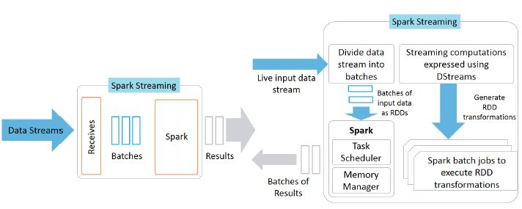

**That application can be used by thousands of users, where they can be doing many clicks and you want to collect those click streams. So these are basically the endless incoming data, which is called incoming data stream or streaming data.**



**Why Streaming in Spark?**

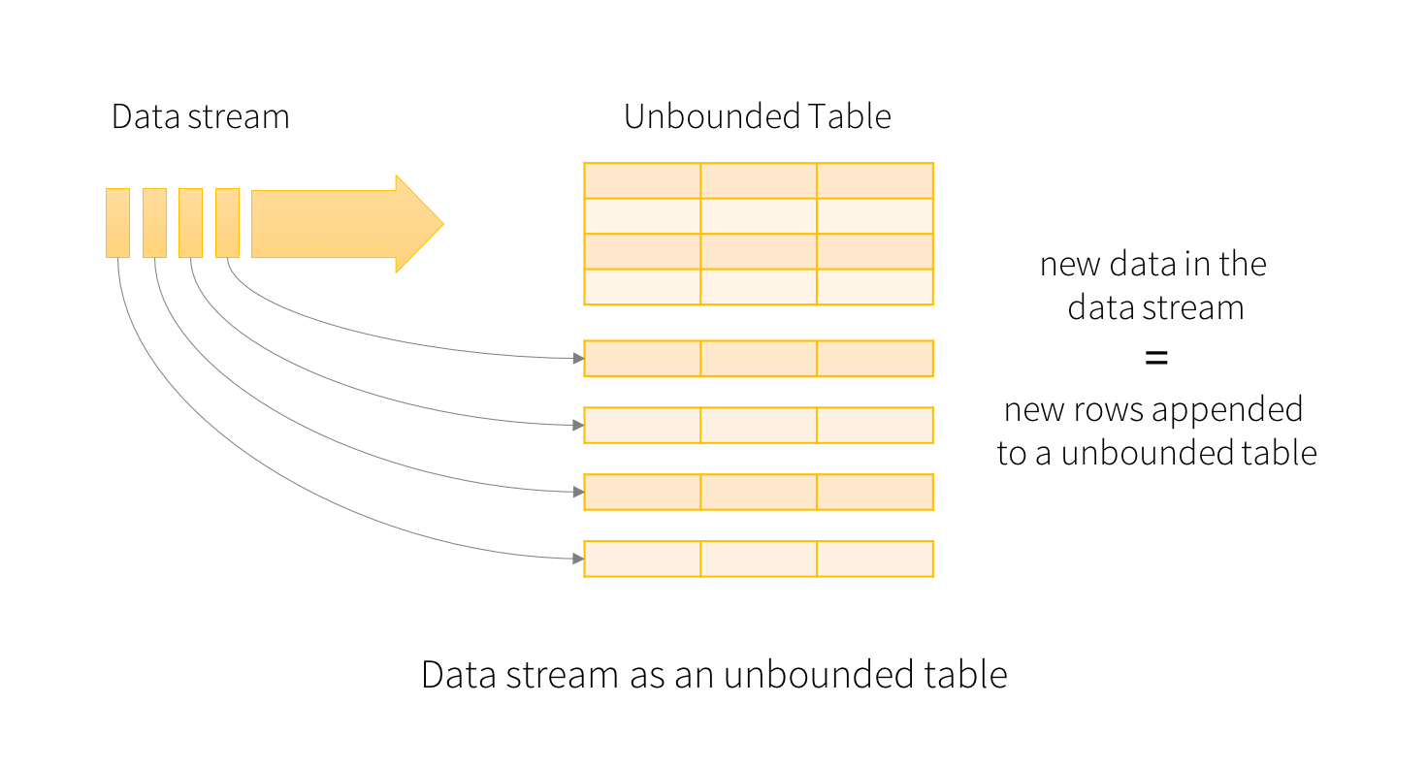

**Batch processing systems like Apache Hadoop have high latency that is not suitable for near real time processing requirements.**

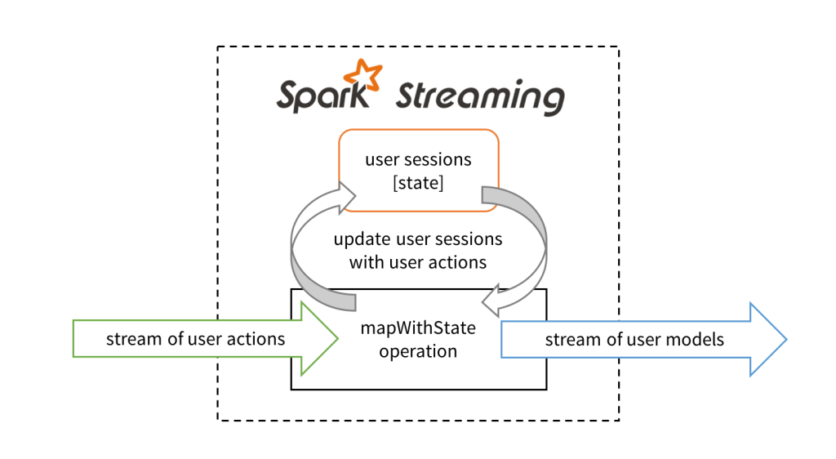

**There is a set of worker nodes, each of which runs one or more continuous operators. Each continuous operator processes the streaming data one record at a time and forwards the records to other operators in the pipeline.**

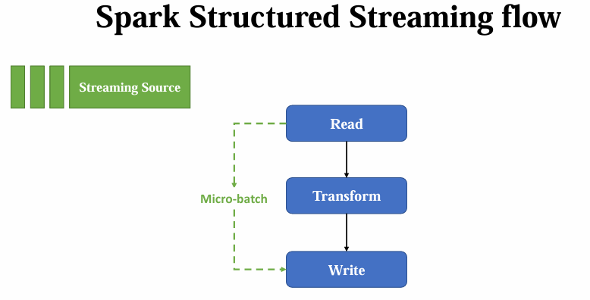

**Data is received from ingestion systems via Source operators and given as output to downstream systems via sink operators.**

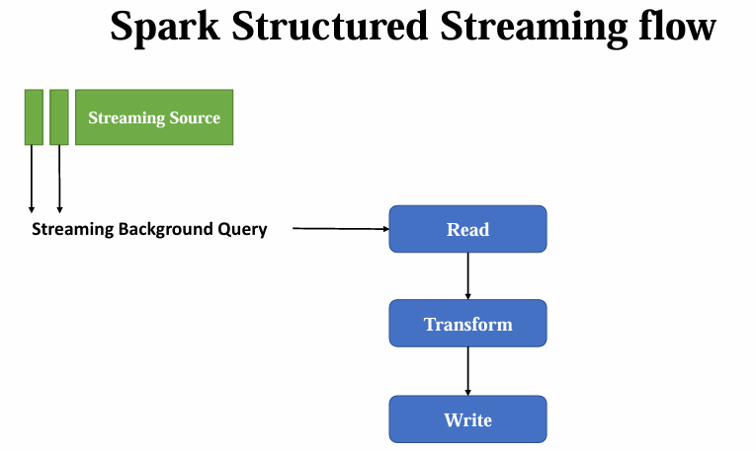

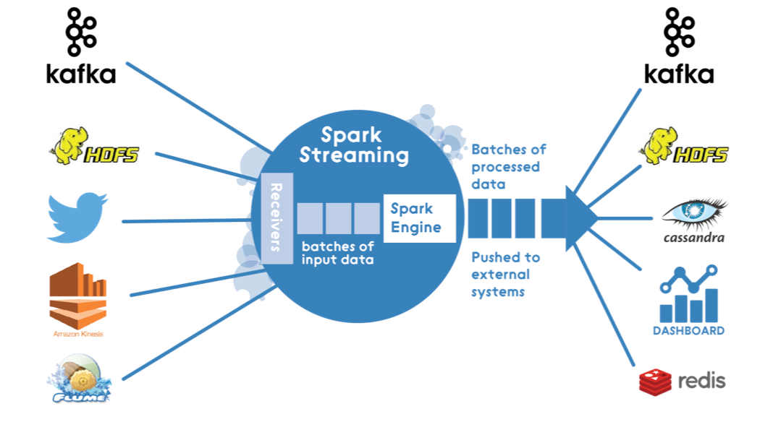

* **Continuous operators are a simple and natural model. However, this traditional architecture has also met some challenges with today’s trend towards larger scale and more complex real-time analytics.**



**Advantages:**

**a) Fast Failure and Straggler Recovery**

**In real time, the system must be able to fastly and automatically recover from failures and stragglers to provide results which is challenging in traditional systems due to the static allocation of continuous operators to worker nodes.**

**b) Load Balancing**

**In a continuous operator system, uneven allocation of the processing load between the workers can cause bottlenecks. The system needs to be able to dynamically adapt the resource allocation based on the workload.**

**c) Unification of Streaming, Batch and Interactive Workloads**

**In many use cases, it is also attractive to query the streaming data interactively, or to combine it with static datasets (e.g. pre-computed models). This is hard in continuous operator systems which does not designed to new operators for ad-hoc queries. This requires a single engine that can combine batch, streaming and interactive queries.**

**d) Advanced Analytics with Machine learning and SQL Queries**

**Complex workloads require continuously learning and updating data models, or even querying the streaming data with SQL queries. Having a common abstraction across these analytic tasks makes the developer’s job much easier.**

**Step 1: Understanding micro batches and background query: This hands on can be done on Databricks community addition, otherwise, it may incur a substantial expense.**

**Note: Each unit in streaming is called as micro-batch and it is the fundamental unit of processing.**

* **Create a compute resource and create a notebook and run the file named as : “Day 10 Streaming+basics.ipynb”.**



* **Upload the file ”Countries1.csv” to “FileStore” in “DBFS”, create a new directory named “streaming”.**
* **Once we have read the data using “readStream” function, let’s see what jobs it has initiated, go “Compute” resource from right top, click on “Spark UI”.**
* **By observing, we can see in “Saprk UI” no job has been initiated, only jobs are created when we are trying to get some data.**
* **For streaming data frames, most of the actions are not supported, but transformations are supported.**
* **If you trying to use show method, it’s not working, “df.show()”.**
* **Instead, use display method, “display(df)”, streaming data is something it is going to accept the files under the particular directory.**
* **Now job is still running and it is displaying the data to us, display “dashboards” which is just below “display(df)”, it’s showing statistic graphs.**
* **Go “Compute” resource from right top, click on “Spark UI”, and see agin, there is “Executor driver added”.**
* **Upload the second file ”Countries2.csv” to “FileStore” in “DBFS”, in “streaming” directory, .**
* **Now go to “notebook” again, observe that data is again processing in “Input vs Prcoessing Rate”, there is a spike indicating new data is available.**
* **In “Spark UI”, there are two jobs, means for each data there is one job it is going to read data.**
* **In “Spark UI” tab, click on “Structure Streaming” there is something called “Display Query”.**
* **Upload the third file ”Countries3.csv” to “FileStore” in “DBFS”, in “streaming” directory, see third micro batch, this streaming query in “Structure Streaming” there is something called “Display Query”, acts as a watcher.**
* **To stop this Streaming Query, you can just click on “cancel” there.**
* **Several other resources available for Live streaming: File source (DBFS), Kafka, Socket, Rate etc. , Socket, Rate Sources are useful for testing purpose not for real deployment. Several sinks are also available.**
* WriteStream **: A query on the input will generate the “Result Table”. Every trigger interval (say, every 1 second), new rows get appended to the Input Table, which eventually updates the Result Table. Whenever the result table gets updated, we would want to write the changed result rows to an external sink.**



 WriteStream = ( df.writeStream

        .option('checkpointLocation',f'{source_dir}/AppendCheckpoint')

        .outputMode("append")

        .queryName('AppendQuery')

        .toTable("stream.AppendTable"))

* **So coming to check pointing it is basically used to store the progress of our stream. Like having the metadata till where the data is copied. Which means if I am just telling some directory, if there is a stream that is available, it is going to read that particular stream, and it is going to write the data to a destination, and it is going to note down till where the data is been copied. It is not going to store the data; it is just going to have the metadata till where the point is copied. And what exactly is the use of this check pointing.**

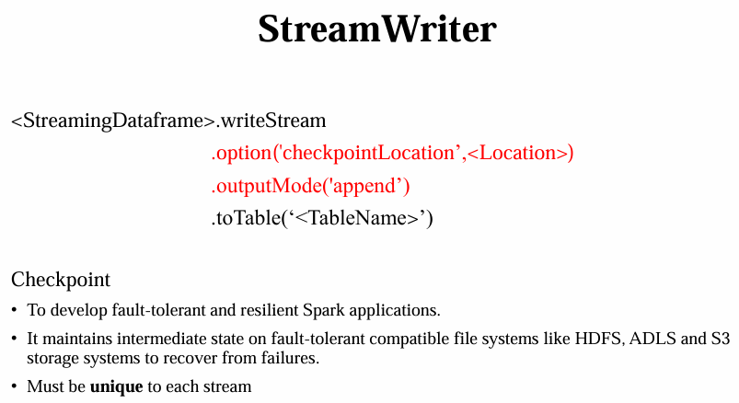

* **So it is going to give the fault tolerance and resiliency to our streaming data. So the terms that you are seeing over there, it is to develop the fault tolerant and resilient spark applications.**
* **So to better understand the fault tolerance and the resilient terms, if there is any failure that occurs during the copy of this particular stream, spark is smart enough to start from the point of failure because it is going to store the intermediate metadata in the checkpoints. It will go to the checkpoint location, and it is going to see till where the data is copied, and it is going to begin the data copy from there.**



* **So this gives the fault tolerant to this particular spark structure streaming, where the intermediary of the state is copied to particular directory.**
* **To check “appendtable” files: got to “Database Tables”-> “Stream”-> “appendtable”.**
* **To check parquet files: got to “DBFS”-> “user”->”hive”->”warehouse”-> “stream.db”.**
* **In “Spark UI” tab, click on “Structure Streaming” there is something called “AppendQuery”.**
* **In “DBFS”, in “streaming” directory, find “AppendCheckPoint”, upload file “Countries4.csv”, after executing following code:**

WriteStream = ( df.writeStream

        .option('checkpointLocation',f'{source_dir}/AppendCheckpoint')

        .outputMode("append")

        .queryName('AppendQuery')

        .toTable("stream.AppendTable"))

* **Keep in mind that: the community edition was designed in a way if the cluster is been terminated, and if you try to create a new cluster, previous databases will not persist, but folder “stream.db” still exists, but “stream.db” won’t show any data when run in sql query. This is not issue with Azure databricks.**
* **Now run “Day 10 outputModes.ipynb” file.**

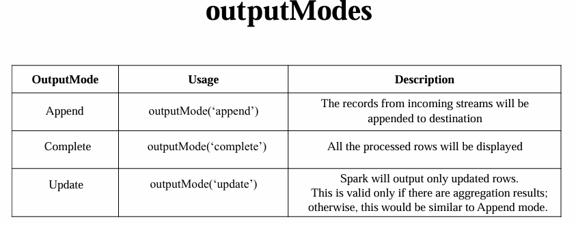

* **OutputMode: The outputMode option in Spark Structured Streaming determines how the streaming results are written to the sink. It specifies whether to append new results, complete results (all data), or update existing results based on changes in the data.**
* **When defining a streaming source in Spark Structured streaming, what does the term "trigger" refer to?**
* **Answer: It triggers the start of the streaming application.**
* **Also run “Day 10 Triggers.ipynb” file, how do we know that it actually checked the input folder to know that click on click on “Structure Streaming”, in “Spark UI” tab, then click on “Run ID” in “Active Streaming Queries”.**

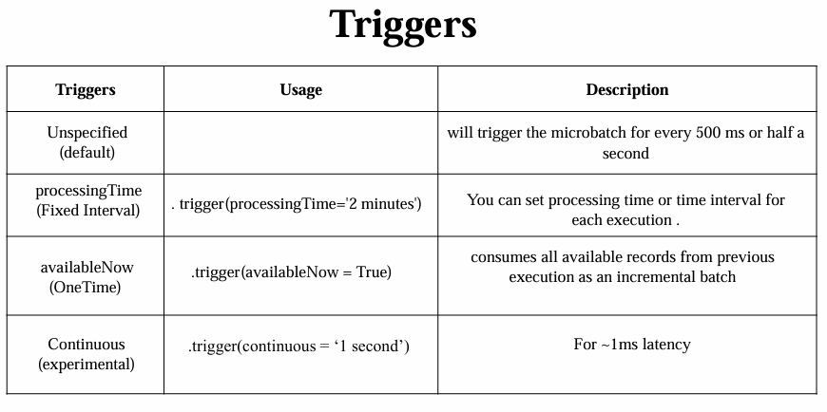

* **Resource:** [**https://spark.apache.org/docs/3.5.3/structured-streaming-programming-guide.html**](https://spark.apache.org/docs/3.5.3/structured-streaming-programming-guide.html)
* **Resource: https://sparkbyexamples.com/kafka/spark-streaming-checkpoint/**

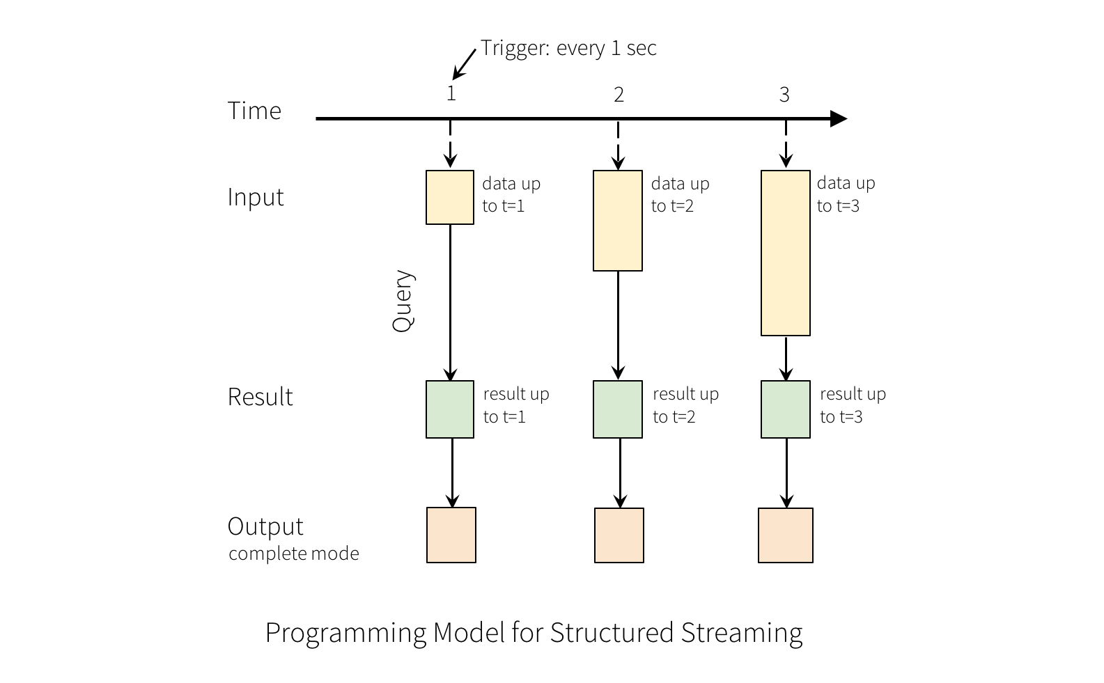

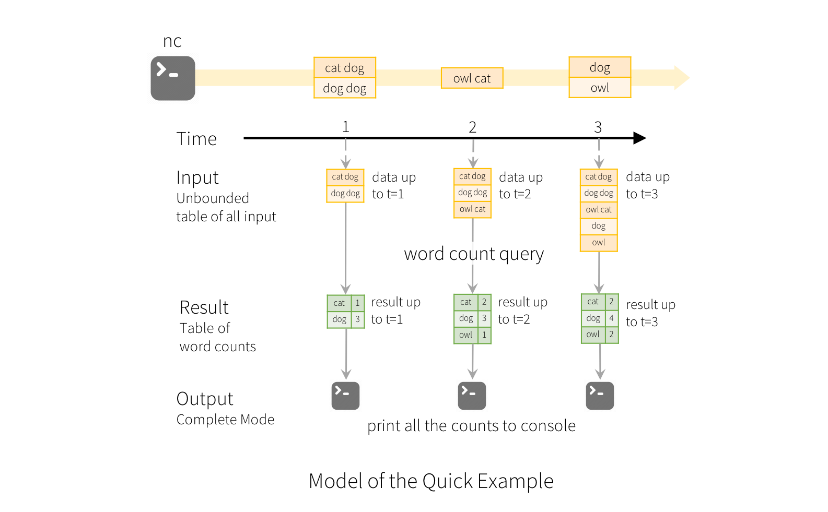



# Day 11: Autoloader – Intro, Autoloader - Schema inference: Hands-on

**Note: This hands on can be done on Databricks community addition, otherwise, it will result in a significantly high bill.**

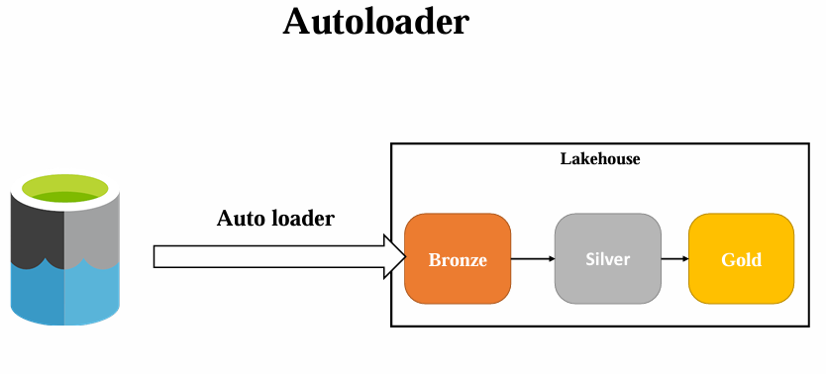

**Why Autoloader?: In this session, let us now see about the auto loader, Let us first understand what exactly is the need of the auto loader before directly going to the definition.**

* **So in the real time project we will always have cloud storage where it is going to store our files. So in order to implement medallion architecture or Lakehouse architecture, we will generally read these files from cloud storage to a bronze layer.**

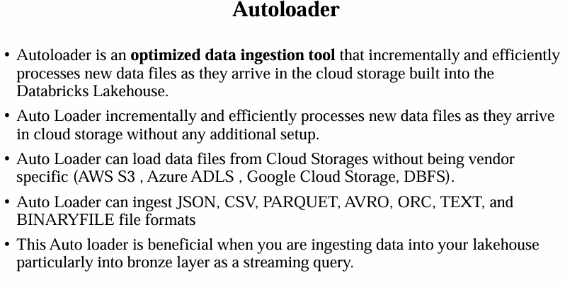

* **And from the bronze layer we are going to do the silver and gold and the downstream transformations in a medallion or a lake house project.**
* **Now, in order to get these files from cloud storage, which is like Azure Data Lake in Azure or a lake house project, and we need to ingest the cloud files or the files available in the cloud storage to bronze layer.**
* **So in order to ingest these files, you need to take care of many things. We need to ingest these files incrementally. And there can be billions of files inside the cloud storage. So you need to build a custom logic to handle the incremental loading.**



* **And also this would be quite complex task for any data engineer to set up an incremental load.**
* **Now we also need to handle the bad data. When you are trying to load this to the bronze layer, you need to handle the schema changes and things, etc. all these needs a complex logic to customize and handle these while reading the data from the data lake to bronze layer. So all these can be supported without explicitly defining any custom logic by making use of auto loader.**
* **So auto loader is a feature in the spark streaming, which can handle billions of data incrementally, and it is the best suited auto loader tool to load the data from the files in the cloud storage to bronze layer.**

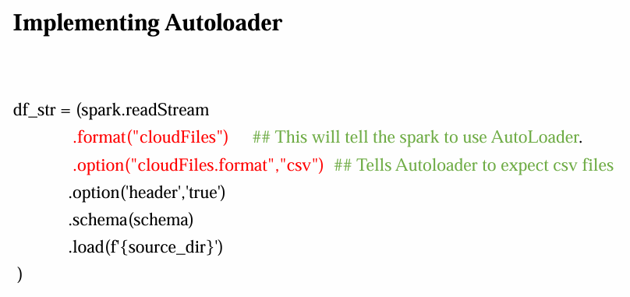

* **So this is the best beneficial tool when you are trying to ingest the data into your lake house, particularly into the bronze layer as a streaming query, where you can also benefit by making use of triggers. And you can implement this auto loader as a tool, which it can take care of everything for you.**



**Hands-on: run “Day 11 Autoloader+-+Schema+Evolution.ipynb” file**

* **Inside this file, .format(‘cloudFiles’), this will tell the spark to use the auto loader here, Cloud files is kind of an API that spark uses to use the auto loader feature.**

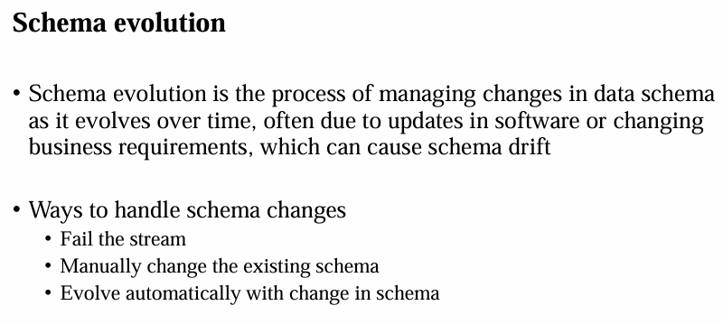

* **Now we have something called schema where we are trying to define the explicit schema. Now auto loader is smart enough to identify the schema of our source.**

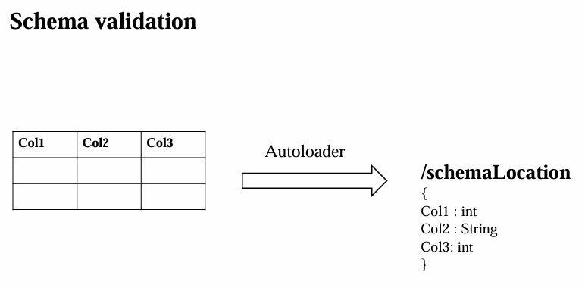

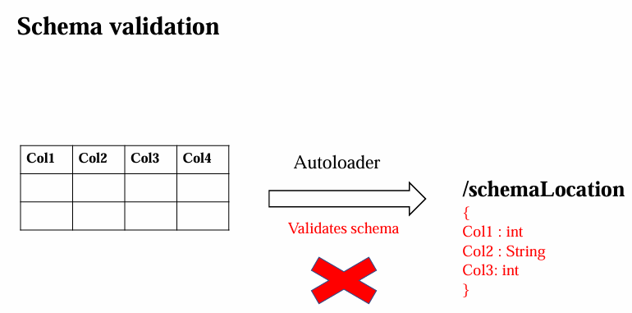

* **So you can just feel free to remove this. And all you need to do is you just need to add something called schema location.**
* **So the schema location path is required because first when it is trying to read the file, it is going to understand the schema of this particular data frame.**
* **“schemaInfer”: So auto loader will first try to read the 100 files or the first 50 GB files. And it is going to conclude that this is the schema which it is going to expect. Now that schema will be written to a path where for the further reading, it is going to refer to that particular schema location.**



**Schema Evolution: if you are having data ingestion with four columns today and tomorrow, due to some business requirements, there could be a new column to be introduced.**

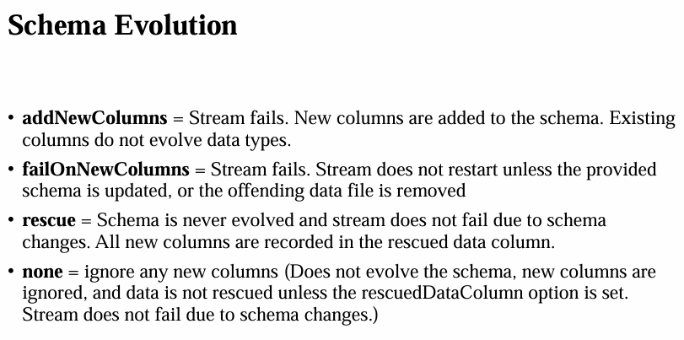

* **This will cause a change in the existing schema where we need to evolve our schema, which is called the schema evolution.**



# Day 12: Project overview: Creating all schemas dynamically

**Medallion Architecture: Let us understand about the medallion architecture. So data engineering is all about quality.**

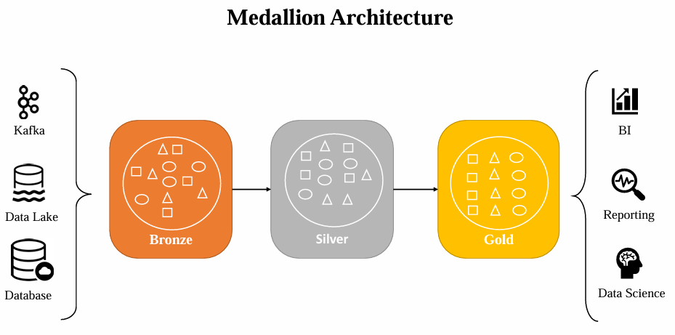

* **The goal of the modern data engineering is to distill data with a quality that is fit for downstream analytics and AI. With the Lakehouse, the data quality is achieved on three different levels.**
* **On a technical level, data quality is guaranteed by enforcing and evolving schemas for data storage and ingestion.**
* **On an architectural level, the data quality is often achieved by implementing the medallion architecture, where the data that is flowing on through each and every layer in the medallion architecture increases the quality.**



* **The Databricks Unity Catalog comes with the robust data quality management, with built in quality controls, testing, monitoring, and enforcement to ensure accurate and useful data is available.**
* **Now with all this, let's understand and implement the medallion architecture.**
* **This architecture is often referred as a multi-hop architecture. Medallion architecture is a data design pattern used to logically organize the data in a Lakehouse, with the goal of increasingly and progressively improving the structure and quality of the data as it flows through each layer of the architecture.**



* **Typically we will have three layers bronze, silver, and gold.**
* **So let's understand this architecture end to end, starting from the data sources. So the data sources can be Kafka streaming data lakes which we will generally use it.**
* **Or it can be databases where your data is generally getting ingested. All these will be where the data is coming from.**
* **You can use any of the ETL tool to get this data ingested from an external system. So this generally sits in a data lake folder which we will use in our project. So being specific with Azure we have an Azure Data Factory which is an ETL tool to ingest the data.**
* **There are 90 plus sources which are supported. And it is going to do some initial loading or the copying of the data to a certain folder, where we often call it as a landing zone.**



* **Bronze Layer: Now there comes some medallion architecture and that starts with the bronze layer.**
* **So this bronze layer typically also called as a raw layer. In this the data is first ingested into the system, as is usually in the bronze layer. The data will be loaded incrementally and this will grow in time. The ingested data into the bronze layer can be a combination of batch and streaming, although the data that is kept here is mostly raw. The data in the bronze layer should be stored in a columnar format, which can be a parquet or delta. The columnar storage is great because it stores the data in columns rather than rows. This can provide more option for compression, and it will allow for more efficient querying of the subset of data.**
* **So this is the primary zone where we will have the exact same data that we receive from our sources without having any modification.**
* **So this is going to serve as a single source of truth for the downstream transformations.**



* **Silver Layer: Now next comes would be the silver layer or the curator layer. So this is the layer where the data from the bronze is matched, merged and conformed, or just cleans just enough so that the silver layer can provide the enterprise view.**
* **So all the key business entities, concepts and transactions will be applied here. So basically we perform the required transformations to the data which can give some basic business value and a quality data where we apply our data quality rules to bring some trustworthiness to the data.**
* **Also, few transformations on top of like joining merging the data to bring some sense of it. By the end of this silver layer, we can have multiple tables which are generated in the process of transformation.**
* **And there comes the business level aggregation.**



* **Golden layer: And the next level would be having this data in a gold layer or a processed layer of the lake house. This is typically organized in a consumption ready project. Specific databases.**
* **The golden layer is often used for reporting and uses more denormalized and the read optimized data models with fewer joints. This is where the specific use cases and the business level aggregations are applied. So we mentioned the data will flow through this layer.**
* **And for each and every layer the quality will be increased.**



* **Coming to bronze the data can be raw and completely unorganized. Whereas for silver we are giving some structure by applying some business level transformations. And there can be a situation you can have completely transformed and ready available data in the silver. And sometimes gold is just for having the views where we have the exact data in silver, and in cases there are some times where the gold layer will have a minimal transformations where we will have the completely organized data.**
* **Now this organized data is ready for consumption. So data consumers are the one who use this data to drive the business decisions. It can be like by reporting in the data science. So this is on a typical the medallion architecture where this can be used in the projects like they want with different data sources and the data consumers.**



* **The basic idea is you will have the data flowing throughout these layers, where each layer will have more quality than the previous layer.**
* **And in our project, also, we will implement this architecture by making use of the data bricks.**

**Project Details:**

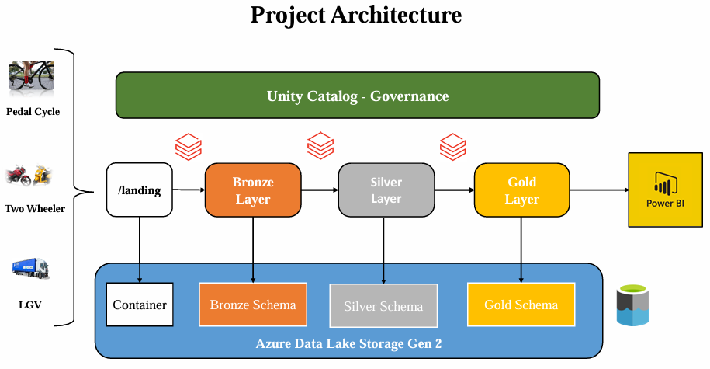

### Project Architecture Script (Main Points)

1. **Introduction**
   * Recap: Medallion architecture overview from the previous video.
   * Current video focus: Specific project implementation of the architecture.
2. **Data Sources**
   * Use **traffic and roads data** as input.
   * Data will be loaded into a **landing zone** (a container in the data lake).
3. **ETL and Data Ingestion**
   * Typical projects use ETL tools like **Azure Data Factory** for incremental data ingestion.
   * For this course: Manual data input into the landing zone to focus on **Databricks learning**.
   * Multiple approaches exist for ingestion pipelines (not the main focus here).
4. **Landing Zone**
   * Located in **data lake storage** under a specific container.
   * Data manually uploaded for simplicity.
5. **Bronze Layer**
   * Purpose: Store raw data from the **landing zone**.
   * Implementation:
     + Use **Azure Databricks notebooks** to ingest data incrementally.
     + Store data in tables under the **bronze schema** (backed by Azure Data Lake).
   * Transformations: Perform on **newly added records only**.
6. **Silver Layer**
   * Purpose: Perform transformations to refine data.
   * Implementation:
     + Create **silver tables** stored under the **silver schema** in Azure Data Lake.
     + Apply detailed transformations on bronze layer data.
7. **Gold Layer**
   * Purpose: Provide **clean and minimal-transformed data**.
   * Implementation:
     + Create **gold tables** under the **gold schema** in Azure Data Lake.
8. **Data Consumption**
   * Final output used by:
     + **Analytics teams**, **data scientists**, and others.
   * Data visualization: Import into **Power BI** for insights.
9. **Governance**
   * Govern and back up the entire pipeline with **Unity Catalog**.
10. **Conclusion**
    * Recap of the end-to-end implementation and project focus on Databricks.



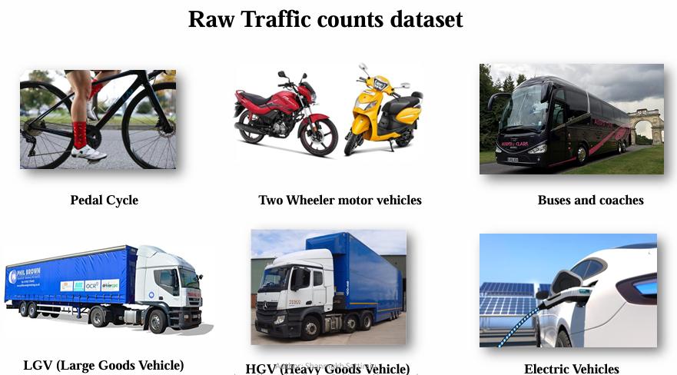

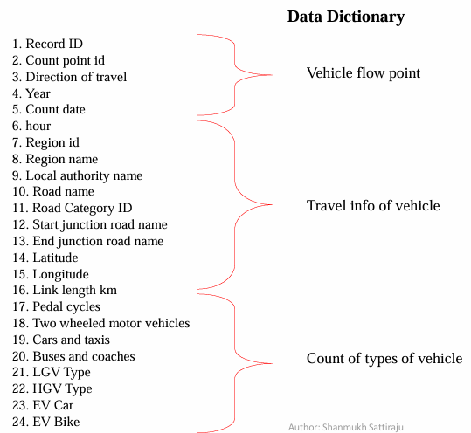



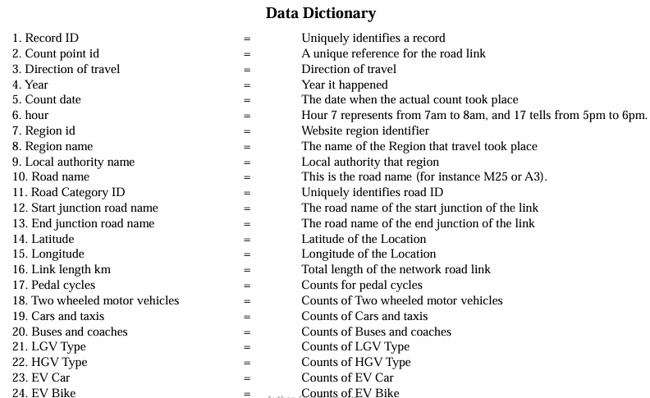

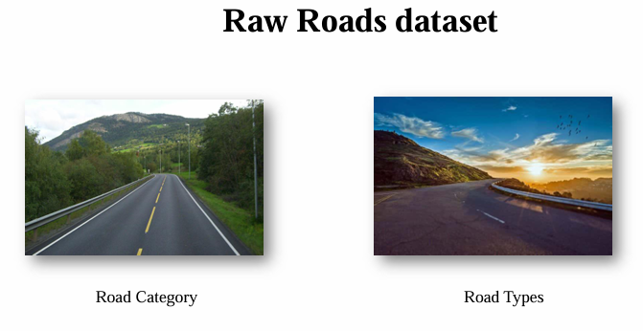



* **Expected Setup pre-requisitive: We need to set up a multi-hop architecture setup. In lack house architecture, we have Bronze, Silver and Golden Layers.**

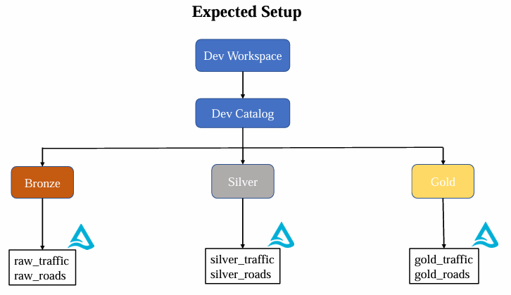

* **And we are going to create the two tables which are raw traffic and the raw roads. But let us now see the complete setup so that you can get an idea on what are the tables we are going to create and what format they should be in.**
* **So once these tables are created and once these are having the data, like taking the data from the landing to bronze, so the raw traffic and the raw Rhodes will have the data and we will perform the required transformations on them.**



* **Hands-on Activity in Azure portal: Create three containers, first container will be “Landing container”, which will consist both “traffic” and “roads” datasets.**

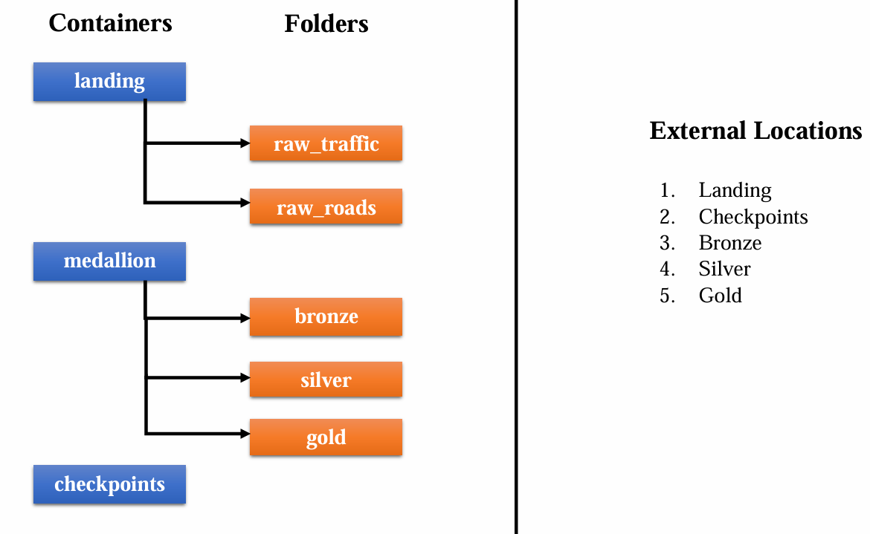

* **Hands-on Activity in Azure portal: Create three containers, “landing”, “medallion”, and ”checkpoints”.**
* **In “landing” containers, create two directories: “raw_roads” and “raw_traffic”.**
* **Now in “medallion” conatiner, create three directories: “Bronze“,“Silver“ and “Golden“.**
* **Hands-on Activity in Databricks portal (which is created through super Admin): inside “Catalog Explorer” click on “External Locations” -> check “Storage Credentials” (you need to create the storage credentials here, because we already have the Databricks Access connector that is having the required role in this particular storage account. So the credentials are already stored by the storage credential. Now you just need to create the external locations.).**



* **Create Five “External locations”:**
* **Create External Locations through “Create Location” button: first “External location name” is “landing”, select “Storage Credential” from default (which is having very big name), provide the link accordingly. “Test Connection”, it must be green for all checks.**
* **Similarly, Create second External Locations through “Create Location” button: “External location name” is “checkpoints”, select “Storage Credential” from default (which is having very big name), provide the link accordingly. “Test Connection”, it must be green for all checks.**
* **Similarly, Create third External Locations through “Create Location” button: “External location name” is “bronze”, select “Storage Credential” from default (which is having very big name), provide the link accordingly. “Test Connection”, it must be green for all checks. Give extra path at the end of “URL” “/bronze”, bcs we have extra directory there.**
* **Similarly, Create forth External Locations through “Create Location” button: “External location name” is “silver”, select “Storage Credential” from default (which is having very big name), provide the link accordingly. “Test Connection”, it must be green for all checks. Give extra path at the end of “URL” “/silver”, bcs we have extra directory there.**
* **Similarly, Create fifth External Locations through “Create Location” button: “External location name” is “gold”, select “Storage Credential” from default (which is having very big name), provide the link accordingly. “Test Connection”, it must be green for all checks. Give extra path at the end of “URL” “/gold”, bcs we have extra directory there.**

# Day 13: Ingestion to Bronze: raw_roads data to bronze Table

**Reference: To be published**

**Details: to be added**

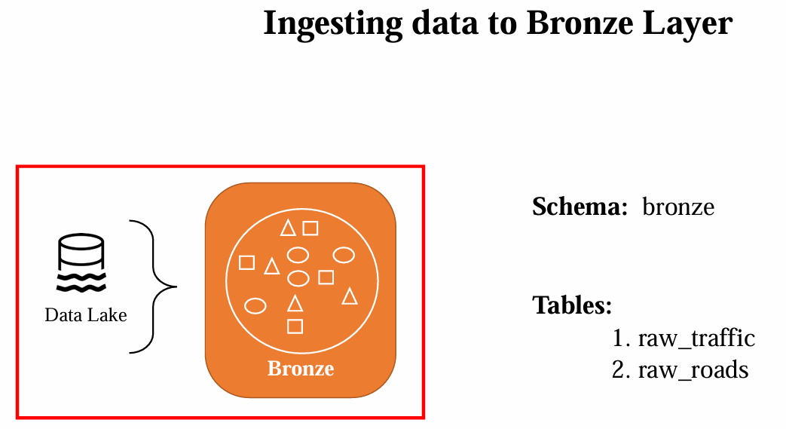



# Day 14: Silver Layer Transformations: Transforming Silver Traffic data

**Reference: To be published**

**Details: to be added**



# Day 15: Golder Layer: Getting data to Gold Layer

**Reference: To be published**

**Details: to be added**



# Day 16: Orchestrating with WorkFlows: Adding run for common notebook in all notebooks

**Reference: To be published**

**Details: to be added**



# Day 17: Reporting with PowerBI

**Reference: To be published**

**Details: to be added**



# Day 18: Delta Live Tables: End to end DLT Pipeline

**Reference: To be published**

**Details: to be added**



# Day 19: Capstone Project I

**Reference: To be published**

**Details: to be added**



# Day 20: Capstone Project II

**Reference: To be published**



**Details: to be added**